|  |  |  |  |  |
| --- | --- | --- | --- | --- |
| 3 | D.GOPI KRISHNA | ILM | 2-2.5LPA | MECHANICAL |
| 4 | E.RAMIREDDY | ILM | 2-2.5LPA | MECHANICAL |
| 5 | K.LAVA KUMAR | ILM | 2-2.5LPA | MECHANICAL |
| 6 | P.RAJESH | ILM | 2-2.5LPA | MECHANICAL |
| 7 | R.VENKATESH | ILM | 2-2.5LPA | MECHANICAL |
| 8 | Y.NAGA RAJU | ILM | 2-2.5LPA | MECHANICAL |
| 9 | D.HARINADH | ILM | 2-2.5LPA | MECHANICAL |
| 10 | M.SIVA SHANKAR | ILM | 2-2.5LPA | MECHANICAL |
| 11 | B.SIVA KRISHNA | WEST LINE SHIPMANAGEMENT | 2.7-3.5LPA | MECHANICAL |
| 12 | M.SAIDA RAO | WEST LINE SHIPMANAGEMENT | 2.7-3.5LPA | MECHANICAL |
| 13 | V.S.L.NARAYANA | WEST LINE SHIPMANAGEMENT | 2.7-3.5LPA | MECHANICAL |
| 14 | SK.M.BHASHA | WEST LINE SHIPMANAGEMENT | 2.7-3.5LPA | MECHANICAL |

**2016-17 Placements**

|  |  |  |  |  |
| --- | --- | --- | --- | --- |
| Sl.No. | Name of the student | Name of the company | Pay Package | BRANCH |
| 1 | A.V.V.BRAMHAM | ILM | 2-2.5LPA | MECHANICAL |
| 2 | BABLU KUMAR | ILM | 2-2.5LPA | MECHANICAL |
| 3 | K.KOTESWAR RAO | ILM | 2-2.5LPA | MECHANICAL |
| 4 | K.MAHESH KUMAR | ILM | 2-2.5LPA | MECHANICAL |
| 5 | M.SRINU | ILM | 2-2.5LPA | MECHANICAL |
| 6 | NOOR BASHA MOHINUDDIN | ILM | 2-2.5LPA | MECHANICAL |
| 7 | N.V.SAI | ILM | 2-2.5LPA | MECHANICAL |
| 8 | P.VIJAY KUMAR | ILM | 2-2.5LPA | MECHANICAL |
| 9 | P.KOTESWAR RAO | ILM | 2-2.5LPA | MECHANICAL |
| 10 | A.L.M.KARUNAKAR | WEST LINE | 2.7-3.5LPA | MECHANICAL |
| 11 | MOHAMMAD SUBHANI | WEST LINE | 2.7-3.5LPA | MECHANICAL |
| 12 | BOJEDLA PULLARAO | WEST LINE | 2.7-3.5LPA | MECHANICAL |
| 13 | DUDEKULA MOULAL | WEST LINE | 2.7-3.5LPA | MECHANICAL |
| 14 | MOGULURI GOPI | WEST LINE | 2.7-3.5LPA | MECHANICAL |
| 15 | SHAIK AFREEDI | WEST LINE | 2.7-3.5LPA | MECHANICAL |
| 16 | DARAPUNENI POLAIAH | WEST LINE | 2.7-3.5LPA | MECHANICAL |
| 17 | KATTI KISHORE | WEST LINE | 2.7-3.5LPA | MECHANICAL |
| 18 | SHAIK SOHAILBAJI | WEST LINE | 2.7-3.5LPA | MECHANICAL |
| 19 | RAVIPATI SIVA KRISHNA | WEST LINE | 2.7-3.5LPA | MECHANICAL |
| 20 | BUDDA KOTESWARARAO | WEST LINE | 2.7-3.5LPA | MECHANICAL |
| 21 | IRAGALA HEMADRI | WEST LINE | 2.7-3.5LPA | MECHANICAL |

**CONTACT**

**MASTER OF COMPUTER APPLICATION(MCA)**

**MCA**

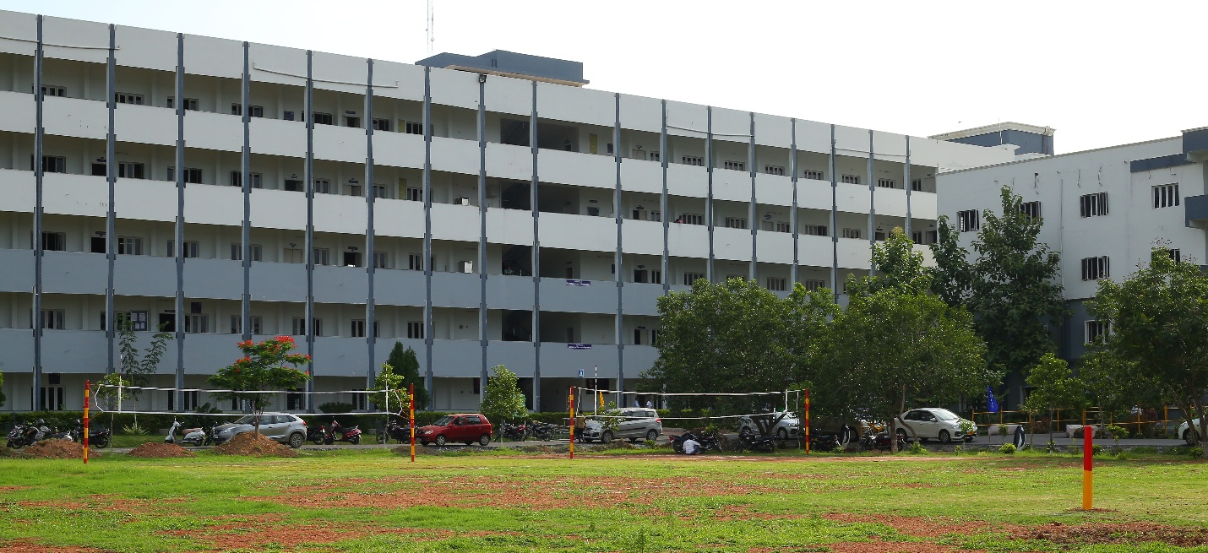

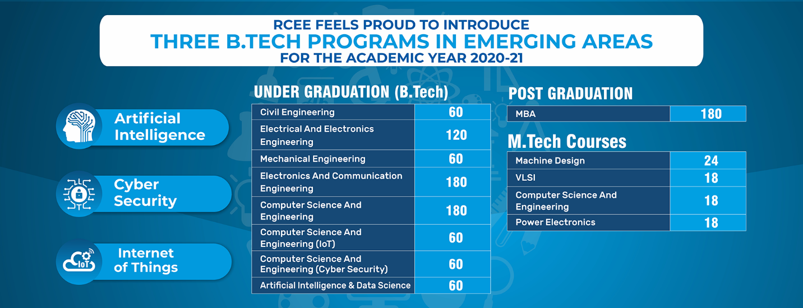

**ABOUT**

**ABOUT US**

Department Profile

The MCA program at NRIIT started in the year 2009 with an intake of 60, approved by AICTE, New Delhi and Affiliated to JNTU, Kakinada. It is extended to 120 in 2014. It is designed to cultivate the leadership and decision making skills necessary to tackle the challenges offered by today's global business. The system planned here is to provide an applied business education in a multi-cultural learning environment to all management students. As NRIIT-MCA’s, improvement in decision making capabilities can be observed, as we provide a functional business foundation to enhance their analytical, communication, and Managerial skills to meet the upcoming challenges in competitive business environment.

The department of comprise of self motivated, committed and enthusiastic faculty members. Personal attention to each student is shown. The faculty are encouraged in dissemination of research based knowledge through conferences, workshops and FDPs. Mentors are attached to each class who would understand the problems of students and for counseling. Personality development classes are regular feature of this department. Teaching methodology including discussions on case studies, regular assignments, class tests for quality education. Industry institute Interaction is a dominant feature of the department.

The Department has equipped with well-stocked Library. The department has full-fledged and latest equipment to suit the needs of student community. The faculty members of the Department are specialized in the fields of Finance, Human Resource, Marketing Management.

Aim of the Department:

• Prepare students to communicate their ideas effectively  
• Prepare students to synthesize, analyse, and integrate their knowledge of business disciplines to provide innovative and credible solutions to organizational problems and opportunities.  
• Prepare students to analyse ethical implications of business decisions.  
• Prepare students to assess the impact of globalization on business.

Vision of the Department

To be the source of bringing out globally competent pioneering computing professionals, researchers, innovators and entrepreneurs and thereby succeed and contribute value to the knowledge-based economy and society.

Mission of the Department:

•To offer high-grade, value-based Post-graduate and Doctoral programmes in the field of Computer Applications.  
•To provide conducive environment so as to achieve excellence in teaching-learning, and research and development activities.  
•To bridge the gap between industry and academia by framing curricula and syllabi based on industrial and societal needs.  
•To offer tasks for experiential technology-intensive knowledge through collaborative and interdisciplinary activities.  
•To provide appropriate forums to develop innovative talents, practice ethical values and inculcate as enduring learners.  
•To facilitate students to nurture skills to practice their professions compete competently to meet the ever-changing needs of society.

Program Specific Objectives (PSOs)

PSO1: To ensure that Post Graduates get good employment.  
PSO2: To make Post Graduates sole Traders & Entrepreneurs.  
PSO3: To make Post Graduates pursue research Work in the area of their domain.

Program Educational Objectives(PEOs)

PEO1: Post Graduate of the program will contribute to the creation, transmission and application of knowledge in the field of management.  
PEO2: Post Graduate of the program will be equipped with quantitative and qualitative skills to identify, analyze, design and create business opportunities in a dynamic environment.  
PEO3: Post Graduates of the program will acquire necessary managerial skills to think strategically and to lead, motivate and manage teams thereby enhancing managerial effectiveness.  
PEO4: Have attained a general level of competence in management and to enable them to act with creative, innovative and entrepreneurial potentials with management tools.  
PEO5: Post Graduates of the program will be able to implement corporate governance and societal values in the real life situation with professional ethics.

**ACADEMICS**

**Under Construction...**

**FACULTY**

**Under Construction...**

**CAMPUS LIFE**

**Campus Facilities**

The institute attracts the cream of student community from across the country through national level competitive examinations and interviews. It believes that the true potential of such students cannot be realized through academics alone. The students are provided with opportunities for exploring and enhancing their talents in extra- curricular activities through Literary, Cultural and Sports clubs. This helps to promote self- management skills and core values in the students, all of which cumulatively help to groom the students into integrated personalities.

The students are involved in a host of other activities. All major events like youth festivals; technical competitions are actively organized and conducted by the student body. There is student representation on various administrative committees like Hostel Governing Body, Canteen Committee, Course Monitoring, Discipline Committee etc. All Student committees function under the peripheral supervision of faculty. Students thus get an opportunity to shoulder responsibility and understand better the issues, challenges and compulsions that are part and parcel of the day-to-day administration of an organization, which indirectly provides for rich experiential learning in the Science of Management.

**General Amenities**

The campus has State Bank of India, SBI ATM, Post Office, courier service, a bookstore for text books and stationery, Copier facilities and Ambulance facilities within the campus.

Canteen facility is made available to cater snacks, coffee, tea and other refreshments to the students and the staff members throughout the college hours.

The campus has an exclusive health Center which is open to all the students and staff from 9 am to 6 pm. The Health center has Qualified Medical Officer and three nursing staff.

* Hospital
* Ambulance
* Post Office
* Stationery Shop

**LIBRARY**

**CENTRAL LIBRARY& INFORMATION CENTER**

**INDEX**

|  |  |  |
| --- | --- | --- |
| S.NO | PARTICULARS | PAGE No’s |
| 1 | LIBRARY ADVISORY COMMITTEE | 3,4 |
| 2 | FUNCTIONS OF LIBRARY | 4 |
| 3 | FACILITIES OF THE LIBRARY | 04-05-2006 |
| 4 | LIBRARY STAFF& LIBRARY WORKING HOURS | 7 |
| 5 | LIBRARY TIMETABLES | 8 |
| 6 | LIBRARY BUDGECT. | 9 |
| 7 | AMOUNT SPENT ON BOOKS,JOURNALS& FACILITIES | 10 |
| 8 | MEMBERSHIP PROCEDURE | 10 |
| 9 | LIBRARY RULES, GENERAL & CIRCULATION |  |
|  | 11-Dec |  |
| 10 | LIST OF BRANCH WISE BOOKS & JOURNALS |  |
|  | Dec-17 |  |
| 11 | OPEN ACCESS E-BOOKS,E-JOURNALS DICTIONARIES & ENCYCLOPEDIAS | 18-21 |
| 12 | LIST OF PROJECTS,JOURNALS BACK VOLUMES & CD COLLECTIONS | 22-23 |
| 13 | LIBRARY SOFTWARE, BAR CODE CIRCULATION SYSTEM & OPAC | 24 |
| 14 | INFRASTRUCTURE FACILITIES | 24 |
| 15 | FILES/RECORDS TO BE MAINTAIEND BY CENTRAL LIBRARY | 25-26 |
| 16 | COLLECTION DEVELOPMENT / STOCK VERFICATION & WEEDING OUT POLICY |  |
|  | 27 |  |

**LIBRARY ADVISORY COMMITTEE**

The committee shall consist of the following members. It considers policy mattersregarding Central Library/Departmental libraries including the policy for procurement of books and journals and render advice to the Purchase Committee for Library procurements.

|  |  |  |  |  |
| --- | --- | --- | --- | --- |
| S. No. | NAME OF THE STAFF | DESIGNATION | CATEGERY |  |
| 1 | Dr. K. SRINIVASU | Principal | Chairman |  |
| 2 | P. TILAK BABU | Executive Director | Convener |  |
| 3 | Dr. M. PANDU | Librarian | Co-Convener |  |
| 4 | Dr. K.SRIHARI RAO | Vice-Principal& HOD | Member |  |
| 5 | B.SEETARAMAIAH | Admin Manager | Member |  |
| 6 | C. AMALA | Asst Professor | ECE | Member |
| 7 | J.RAMU | HOD | CSE, AI & ML | Member |
| 8 | B.V.N.K. SURESH | Asst Professor |  |  |
| 9 | Dr. K. CHANDRA MOULI | HOD | CE | Member |
| 10 | M. CHAITANYA NAVA KUMAR | Asst Professor |  |  |
| 11 | D. KOTESWARA RAO | HOD | IT&DS | Member |
| 12 | P. SUJATHA | Assoc Professor |  |  |
| 13 | Dr. ZIA UR REHAMAN | HOD | MBA | Member |
| 14 | Dr. V.CH. PURNA CHANDRA RAO | Assoc professor |  |  |
| 15 | K. SRINIVASA RAO | HOD | S&H | Member |
| 16 | SP. RANGANATH | Asst Professor |  |  |
| 17 | P. RAVI KUMAR | HOD | ME | Member |
| 18 | B.V R. SAI | Asst Professor |  |  |

**Members of Library Student Committee 2022-23**

|  |  |  |  |
| --- | --- | --- | --- |
| S.No | Name of the Student | Department | Roll Number |
| 1 | B.PAVAN KUMAR NAIK | CIVIL II-A | 21KP1A0102 |
| 2 | K.DURGA BHAVANI | CIVIL II-B | 21KP5A0104 |
| 3 | L.CHITRA | CIVIL III-A | 20KP1A0105 |
| 4 | B.KRISHNA | CIVIL III-B | 19KP1A0102 |
| 5 | M.SIREESHA | CIVIL IV-A | 19KP1A0110 |
| 6 | K.SAILAJA | CSE II-A | 19KP1A0547 |
| 7 | P.BALA KRISHNAVENI | CSE II-B | 19KP1A0580 |
| 8 | N.NAVEEN | CSE III-A | 20KP1A0570 |
| 9 | R.MANOHAR | CSE III-B | 21KP1A0588 |
| 10 | I.TRIVENI | CSE IV-A | 21KP1A0531 |
| 11 | G.ROSHITH | ME II | 19KP1A0303 |
| 12 | V J CHANDU | ME III-A | 19KP1A0318 |
| 13 | SK.NAGOOR BASHA | ME III-B | 20KP5A0325 |
| 14 | D. TARAKARAO | ME IV-A | 20KP5A0306 |
| 15 | SK. MAHAMAD KIFE | ME IV-B | 20KP1A0312 |
| 16 | P.LAKSHMI MEGHANA | ECE II-A | 19KP1A0463 |
| 17 | CH.SAI PALLAVI | ECE II-B | 19KP1A0420 |
| 18 | A.PRASANNA | ECE III-A | 19KP1A0405 |
| 19 | D.SUSHMA | ECE III-B | 20KP1A0430 |
| 20 | M.SUMANTH | ECE IV-A | 20KP1A0474 |
| 21 | G.ARCHANA | AIML | 21KP1A6116 |
| 22 | J. INDIRA | AIML | 21KP1A6123 |
| 23 | A.NARENDRA KUMAR | DS | 21KP1A4406 |
| 24 | D.TRIKANTH | CSE | 21KP1A0506 |
| 25 | P.RAVI | MBA | 21KP1E0034 |
| 26 | J.JYOTHI | MBA | 21KP1E0049 |
| 27 | M.TRIVENI | MBA | 21KP1E0027 |
| 28 | M.SAI | MBA | 21KP1E0022 |
| 29 | P.SADIKA | MBA | 21KP1E0036 |
| 30 | K.S.L PAVANI | IT & DS | 20KP1A4415 |
| 31 | D.ANJALI | IT & DS | 20KP1A1209 |
| 32 | P.PADMA SAI | IT & DS | 20KP1A4433 |
| 33 | B.SAHITHI | IT & DS | 20KP1A4403 |
| 34 | CH.JAHANAVI | IT & DS | 20KP1A4405 |

Functions of the Central Library & Information Centre:

1. Monitors the allocation of funds to procure Library books, Journals and magazines and subscription of e-journals.  
2. Procurement of books as per the syllabus.  
3. Subscription of journals and magazines.  
4. To procure required e-learning resources for enhanced learning.  
5. Proper utilization of the Library resources.  
6. Directing and Controlling of Library activities  
7. Defining roles and responsibilities of members  
8. Motivate Library staff to give better service to the Library users

NRI INSTITUTE OF TECHNOLOGY Visadala (V), Medikonduru (M), Guntur Dist-522 438, A.P.

Facilities of the Central Library and Information centre:

Total Library Area: 755 Sqm.

1. Seating capacity: 150  
2. Library Sections:  
• Circulation Section  
• Reading room  
• Reference section  
• Periodical section  
• Digital Library with Internet connectivity, DELNET, J-GATE,and NPTEL video courses  
3. Available Number of Titles: 3255  
4. Available Number of Volumes: 18934  
5. Periodicals (Journals & Magazines): 91  
6. Online Journals: 1068  
7. Open access journals(DELNET) - 1068  
8. Online streaming of NPTEL video courses through LAN  
9. Computer Systems:  
• Digital Library: 28  
• OPAC : 02  
• Other facilities: 02  
10. Reprography  
11. CDs accompanying with Books and Periodicals - 1852  
12. Newspapers-10  
13. Bar-code Readers-2  
14. Bar-code Printer-1  
15. Open Racks :14  
16. Closed Racks: 20  
17. Periodical Racks: 08  
18. New Arrival Racks: 02  
18. Timings : 8.a.m to 6p.m  
19. Number of Library Staff: 4  
20. Number of Library Staff with degree in library Science -3

Library services:

Library services:

->Books can be borrowed in automation .All the books are automated in the Library & barcode scanners are used in the circulation counter for the transaction of books.  
->Regular Books for the students, 4 books can be borrowed for a period of 15 days.  
->Books for the staff will be provided 10 books for a period of one semester.

Reference Services:

Journals, Magazines, Project reports, Encyclopedias Dictionaries etc are available for reference purpose only inside the library.

Internet facility :

36 computers with internet facility is exclusively available for Students and staff members

E – Resources :

NPTEL Videos, DELNET, J-GATE, SWAYAM

5. Question papers :

University Question papers, Gate Previous question papers are readily available

Reprography Services :

Xerox facility is available

Bibliographic Services :

A list of all Books in library is available

OPAC :

Status of Books can be easily found with software and 2 Computers systems are allotted

Library Committee:

The Library has advisory Committee. One staff member from each department and student‘s members are in the committee.

ILL (Inter Library Loan Service): YES:

Information deployment and notification (Information Deployment and Notification) :YES (Notice Boards)

. Feed back / suggestions/complaints box is kept in the library to get feedback from staff and students at any point of time

|  |  |  |  |  |
| --- | --- | --- | --- | --- |
| S.No | Name | Designation | Qualification | Experience |
| 1 | Dr. M. PANDU | LIBRARIAN | M.A.,MLISC.,M.Phil., NET-JRF.,Ph.D. | 7 years |
| 2 | Dr. G.R.SAILAJA | LIBRARIAN | M.A.,MLISC., Ph.D. | 14 years |
| 3 | Y.SRINIVASA RAO | ASSISTANT LIBRARIAN | M.L.I.Sc | 10years |
| 4 | V.RAVI KUMAR | LIBRARY |  |  |
| ASSISTANT | MCA.,M.L.I.Sc | 10 years |  |  |

LIBRARY WORKING HOURS & LIBRARY TIMETABLES LIBRARY WORKING HOURS:

Working days : 8:00 AM to 6 :00 PM  
Sundays : 9:30 AM to 12:30 PM  
Gazetted Holidays : Closed.  
Circulation Hours : 9:00 AM to 5:00 PM  
Reprographic/Xerox Timings : 9:00 AM to 6:00 PM  
Internet Timings : 9:00 AM to 5:00 PM

**ANTI RAGGING**

**TRANSPORTATION**

|  |  |
| --- | --- |
| BUS NO : 1 -ATCHAMPETA | |
| AREA | TIME |
| CHAMARTHI | 7:00 (19500) |
| ATCHAMPETA | 7.10 (19500) |
| KROSUR | 7.25 (17000) |
| PEESAPADU | 7.40 (14500) |
| RENTAPALLA | 7.45 (14000) |
| SATENAPALLI | 8.00 (13000) |
| NRIIT | 8.45 |
| BUS INCHARGE | ( ranghanadh )8985338265 |
| DRIVER | 8374991713 |
|  |  |
| BUS NO : 2- PARSA | |
| AREA | **TIME** |
| PARSA | 7.00 (21000) |
| KAMAMPADU | 7.05 (19500) |
| MANDIPUDI | 7.15 (17500) |
| PAMULAPADU | 7.20 (18000) |
| BESTHAPURAM | 7.25 (15500) |
| RAVELA | 7.35 (14000) |
| PONNEKALLU | 8.00 (13000) |
| NRIIT | 8.45 |
| BUS INCHARGE | ( sirisha ) 9533223845 |
| DRIVER | (ROSAYA) 9912415690 |
|  |  |
| BUS NO : 3 - CHILAKALURIPETA | |
| AREA | TIME |
| PASUMARTHI | 7.00 (23500) |
| KALAMANDHIER | 7.05 (22000) |
| CROSS ROAD | 7.10 (22000) |
| NRT CENTER | 7.15 (22000) |
| GANAPAVARAM | 7.18 (20000) |
| THIMAPURAM | 7.23 (18000) |
| YADLLAPADU | 7.30 (16000) |
| LINGHARAO PALEM | 7.40 (14500) |
| THUPADU CROSS ROAD | 7.50 (14000) |
| NUDHURUPADU CROOS ROAD | 7.55 (14000) |
| SATULURU | 8.00 (15000) |
| PIRANGHIPURAM | 8.15 (13000) |
| VEMULLAPADU | 8.25 (10000) |
| UNIVERSAL COLLEGE | 8.35 (6000) |
| NRIIT | 8.45 |
| BUS INCHARGE | ( SUJATHA) 9912750999 |
| DRIVER | (yesu) 8247481256 |
|  |  |
| BUS NO : 4 - MANGALAGIRI | |
| AREA | TIME |
| MANGALAGIRI | 7.15 (22000) |
| TENALI BYPASS | 7.20 (22000) |
| CHINNA KAKANI | 7.25 (19500) |
| KAZA | 7.30 (18000) |
| Koppuravuru | 7.40 (17500) |
| NUMBUR | 7.50 (17000) |
| PEDDA KAKANI | 8.00 (15500) |
| NRIIT | 8.45 |
| BUS INCHARGE | ( SURESH ) 9492582620 |
| DRIVER | (A.V.S.RAO) 9052625293 |
|  |  |
| BUS NO : 5- VALABAPURAM | |
| AREA | TIME |
| VALABAPURAM | 6.50 (23500) |
| MUNAGI | 6.55 (23500) |
| GUDHIBANDIVAREPALEM | 7.05 (23500) |
| KOLIPARA | 7.10 (23500) |
| THUMULURU CROSS ROAD | 7.15 (22000) |
| ATHOTA | 7.25 (19500) |
| NADHIVELUGU | 7.35 (18000) |
| KOLAKALURU | 7.40 (18000) |
| KAZIPETA | 7.45 (17500) |
| VENKATAKRISHNA PURAM | 7.55 (15500) |
| THAKELAPADU | 8.00 (15500) |
| NRIIT | 8.45 |
| BUS INCHARGE | ( MALESWARI ) 7675865479 |
| DRIVER | (SK.KAMURUDHEEN) 9052309124 |
|  |  |
|  |  |
| BUS NO : 6 -TENALI | |
| AREA | TIME |
| CHENCHUPET | 7.20 (22000) |
| SULTHANABAD | 7.25 (22000) |
| Angalakuduru | 7.30 (19500) |
| VADLAMUDI | 7.45 (18000) |
| NARAKODURE | 8.00 (17000) |
| ETUKURU BYPASS | 8.15 (13000) |
| NALLACHERUVU | 8.20 (13000) |
| NRIIT | 8.45 |
| BUS INCHARGE | ( GAYATHRI ) 9494813704 |
| DRIVER | (BABURAO) 9000088175 |
|  |  |
| BUS NO : 7 -ANDUKURU | |
| AREA | TIME |
| ANDUKURU | 6.45 (17500) |
| GARAPADU | 6.55 (15500) |
| HUSENAGARAM | 7.05 (15000) |
| PEDAKURAPADU | 7.15 (14500) |
| LINGAM GUNTA | 7.25 (13000) |
| PODAPADU | 7.30 (10500) |
| BUSAPURAM | 7.4 |
| PADIBANDLA | 8.15 |
| SIRIPURAM | 8.30 (9000) |
| MEDIKONDURU | 8.40 (4000) |
| NRIIT | 8.45 |
| BUS INCHARGE | ( parvathi ) 8074329473 |
| DRIVER | (SIVAYYA) 9866903446 |
|  |  |
| BUS NO : 8 -TENALI | |
| AREA | TIME |
| ITHA NAGAR | 7.1 |
| SIVAJI STARCHU | 7.15 |
| COURT | 7.17 |
| DEVI CHOWK | 7.2 |
| CHINNARAVURI PARK | 7.25 |
| TELIPHONE EXCHANGE | 7.28 |
| BUS STAND | 7.3 |
| MARKET | 7.35 |
| ANDHRA MUSLIM COLLEGE | 8 |
| SANGADIGUNTA | 8.05 |
| NRIIT | 8.45 |
| BUS INCHARGE | (TONY) 9989273577 |
| DRIVER | (L.J.PRASAD) 9490770855 |
|  |  |
| BUS NO : 9 -KANKANALAPALLI | |
| AREA | TIME |
| KANKANALAPALLI | 7:30 (14500) |
| SATHENAPALI | 8:00 (13000) |
| NANDHIGAMA CROSS | 8.05 (12000) |
| KANTEPUDI | 8.10 (11000) |
| KORRAPADU | 8.20 (11000) |
| PALADUGU CROSS | 8.25 (10000) |
| JAGAMGUNTAPALAM | 8.30 (8000) |
| B.V.PALEM | 8.35 (7000) |
| MEDICONDURU | 8.40 (4000) |
| NRIIT | 8.45 |
| BUS INCHARGE | ( srinu ) 9618193282 |
| DRIVER | (VENKATESWARA RAO) 6303268566 |
|  |  |
| BUS NO : 10 - SANKARVILLS | |
| AREA | TIME |
| SANKARVILLS | 7.45 (13000) |
| HOLLYWOOD BOLLYWOOD | 7.50 (13000) |
| REELINCE | 7.53 (13000) |
| NRI | 7.56 (13000) |
| BEKARS FUN | 8.00 (13000) |
| SETHARAMAYA SCHOOL | 8.05 (13000) |
| GARDENS | 8.07 (13000) |
| KAMMA HOSTEL | 8.10 (13000) |
| SPENSARES | 8.12 (13000) |
| VEKATESWARA SWAMY TEMPUL | 8.13 (13000) |
| RAJENDHRA NAGAR | 8.14. (13000) |
| HANUMAYYA COMPANY | 8.20 (13000) |
| NRIIT | 8.45 |
| BUS INCHARGE | (CH.DHANALAKSHMI ) |
|  |  |
|  |  |
| BUS NO : 11 - GORANTLA 1ST YEAR& STAF | |
| AREA | TIME |
| GORANTLA | 7:55 (13000) |
| NAGARALU | 8:00 (13000) |
| LODGE CENTER | 8.05 (13000) |
| KORITAPADU | 8.10 (13000) |
| VIDYA NAGAR | 8.15 (13000) |
| DMART | 8.20 (13000) |
| GUJJANAGUNDLA | 8.22 (13000) |
| GITHAM HOSTEL | 8.23 (13000) |
| NRIIT | 8.45 |
| BUS INCHARGE | ( Devika ) 9100559532 |
| DRIVER |  |
|  |  |
| BUS NO : 12 - SANKARVILLS | |
| AREA | TIME |
| SANKARVILLS | 7.50 (13000) |
| HOLLYWOOD BOLLYWOOD | 7.55 (13000) |
| REELINCE | 8.00 (13000) |
| NRI | 8.03 (13000) |
| BEKARS FUN | 8.05 (13000) |
| SETHARAMAYA SCHOOL | 8.08 (13000) |
| GARDENS | 8.10 (13000) |
| KAMMA HOSTEL | 8.15 (13000) |
| SPENSARES | 8.18 (13000) |
| VEKATESWARA SWAMY TEMPU | 8.20(13000) |
| RAJENDHRA NAGAR | 8.22 (13000) |
| HANUMAYYA COMPANY | 8.22 (13000) |
| NRIIT | 8.45 |
| BUS INCHARGE | ( t.p.kanakadurgha ) 9100243833 |
|  |  |
| BUS NO : 13 -GORANTLA | |
| AREA | TIME |
| GORANTLA | 7:50 (13000) |
| NAGARALU | 7.55 (13000) |
| LODGE CENTER | 8.00 (13000) |
| KORITAPADU | 8.05 (13000) |
| VIDYA NAGAR | 8.07 (13000) |
| GUJJANAGUNDLA | 8.10 (13000) |
| NRIIT | 8.45 |
| BUS INCHARGE | (chithanya) 8121760067 |
| DRIVER | (RAMARAO) 9985554458 |
|  |  |
| BUS NO : 14- REDDY HOSTEL | |
| AREA | TIME |
| REDDY HOSTEL | 7.50 (13000) |
| ARMY OFFICE | 8.00 (13000) |
| MAHATMA GANDHI COLLEGE | 8.05 (13000) |
| TEMPLE | 8.10 (13000) |
| HOWSING BOARD | 8.15 (13000) |
| NRIIT | 8.45 (13000) |
| BUS INCHARGE | (Anusha) 8367653134 |
| DRIVER | (ANJANEYULU) 9963639092 |
|  |  |
| BUS NO : 15 - MANGALADAS NAGAR | |
| AREA | TIME |
| MANGALADAS NAGAR | 7.50 (13000) |
| VASAVI COMPLEX | 7.53 (13000) |
| KOTHAPETA | 8.00 (13000) |
| NAZZ CENTER | 8.05 (13000) |
| ETTU ROAD | 8.10 (13000) |
| VIJAYALAKSHMI CINIMAHALL | 8.12 (13000) |
| HOWSING BOARD | 8.2 |
| MBTS COLLEGE CENTER | 8.25 |
| NRIIT | 8.45 |
| BUS INCHARGE | ( A.Sainath ) 8919043672 |
| DRIVER | (SUBHANI) 9581021821 |
|  |  |
| BUS NO : 16 - BOYS HOSTEL | |
| AREA | TIME |
| HOSTEL | 7.50 (13000) |
| NRIIT | 8.3 |
| DRIVER | (VINAY) 9848682825 |
|  |  |
| BUS NO : 17 -GIRLS HOSTEL | |
| AREA | TIME |
| GIRLS HOSTEL | 7.50 (13000) |
| NRIIT | 8.3 |
| DRIVER | (MODI) 7569864405 |
|  |  |
|  |  |
| BUS NO : 18- MANIPURAM BRIDGE | |
| AREA | TIME |
| MANIPURAM BRIDGE | 7.50 (13000) |
| NTR STATUE | 7.55 (13000) |
| PATHA BUS STAND | 8.00 (13000) |
| ITC | 8.10 (13000) |
| CHUTUGUNTA | 8.13 (13000) |
| SRIRAM NAGAR | 8.16 (11500) |
| MIRCHI YARD | 8.20 (11500) |
| NRIIT | 8.45 |
| BUS INCHARGE | ( ARCHANA ) 9494184193 |
| DRIVER | (SHANKAR) 9849204996 |
|  |  |
| BUS NO : 19 - PATHAGUNTUR | |
| AREA | TIME |
| BR STADIEM | 7.55 (13000) |
| PATHA BUS STAND | 7.57 (13000) |
| MARKET | 8.00 (13000) |
| 60 FEET ROAD | 8.10 (13000) |
| NALLAPADU | 8.20 (8000) |
| CHALLAVARI PALEM | 8.22 (8000) |
| MBTS COLLEGE CENTER | 8.27 (8000) |
| NRIIT | 8.45 |
| BUS INCHARGE | ( HARITHA ) 8074730522 |
| DRIVER | (RAVI) 9390004262 |
|  |  |
| BUS NO : 20 - BOYS HOSTEL | |
| AREA | TIME |
| HOSTEL | 7.55 (13000) |
| NRIIT | 8.3 |
| DRIVER | (NAGARAJU) 9550756602 |
|  |  |
| BUS N0 : 21- RTO OFFICE ROAD | |
| AREA | TIME |
| DMART | 7.50 (13000) |
| JKC COLLEGE ROAD | 7.55 (13000) |
| RTO RING ROAD | 8.00(13000) |
| SVN COLLANY | 8.05 (13000) |
| GUJJANAGULLA CURENT OFFICE | 8.07 (13000) |
| KALYAN NAGAR | 8.10 (13000) |
| RATHANAGIRI NAGAR | 8.12 (13000) |
| VIGNAN | 8.15 (13000) |
| THURAKAPALEM | 8.17 (13000) |
| PEDDA PALAKALURU | 8.20 (10500) |
| CHINNA PALAKALURU | 8.25 (10500) |
| NRIIT | 8.45 |
| BUS INCHARGE | (BHARHMAM) 8143636370 |
| DRIVER |  |
|  |  |
| BUS NO : 22 - KAMMA HOSTEL | |
| AREA | TIME |
| KAMMA HOSTEL | 8.00 (13000) |
| ARMY OFFICE | 8.10 (13000) |
| NGOS COLLANY | 8.15 (13000) |
| HOUSIN BOARD | 8.20 (11500) |
| NRIIT | 8.45 |
| BUS INCHARGE | ( SAI ) 7306299847 |
| DRIVER | (MASTHAN) 9985239435 |

**T & P**

**GALLERY**

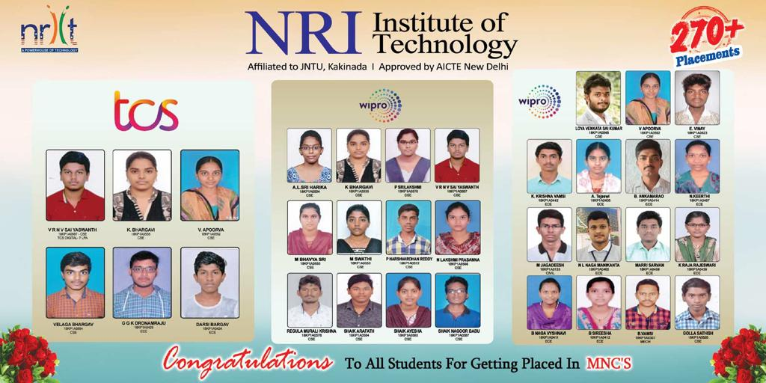

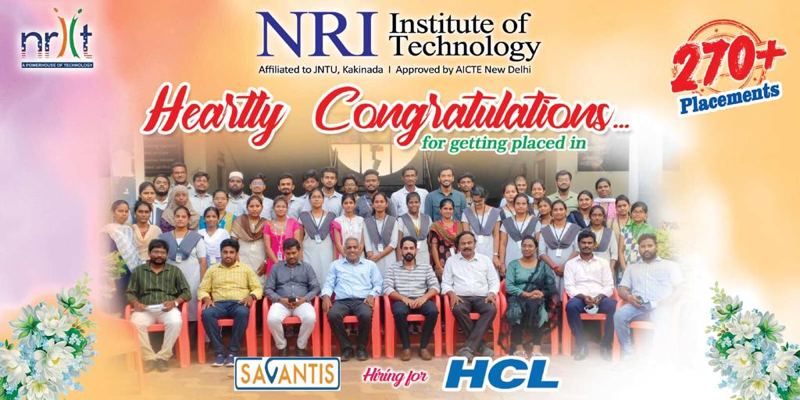

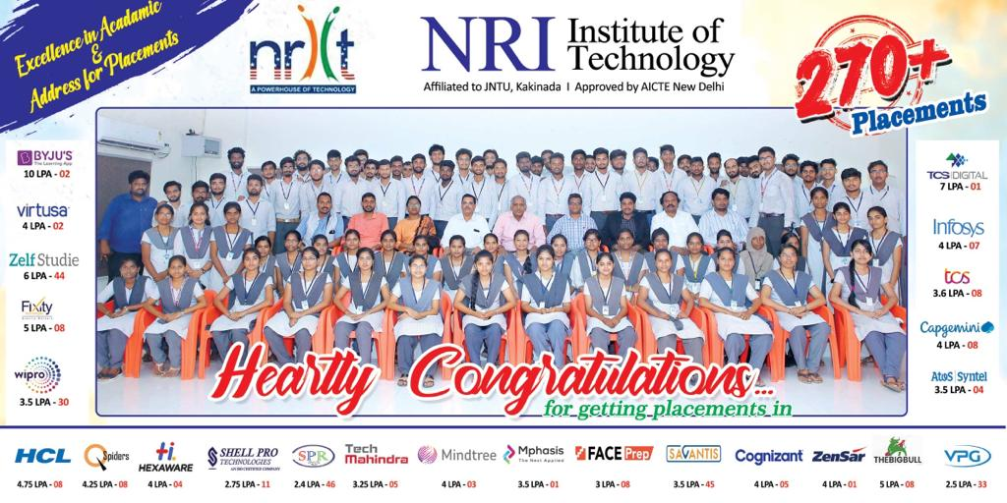

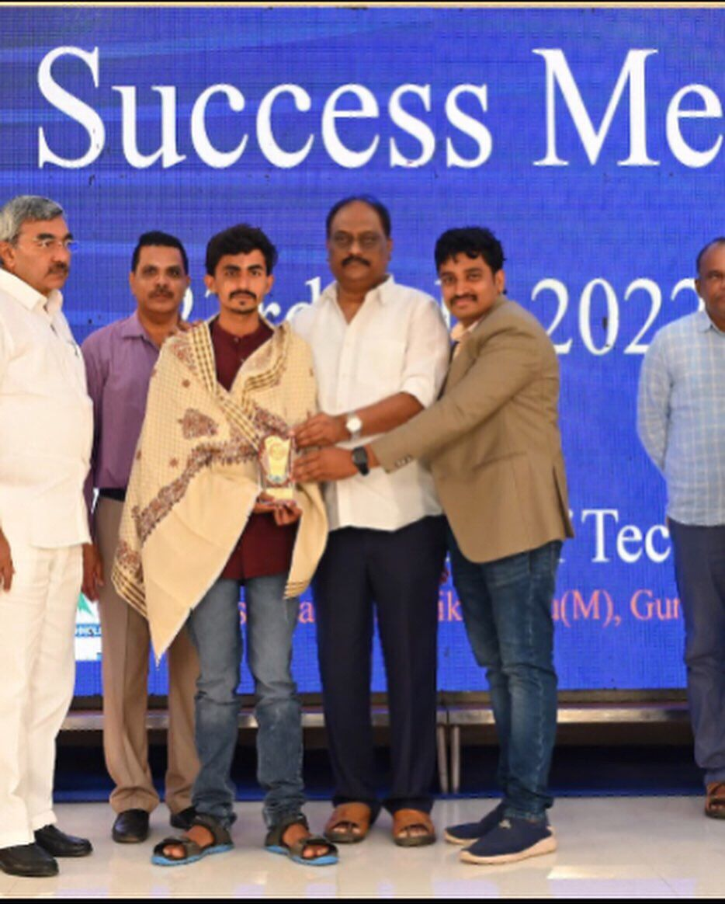

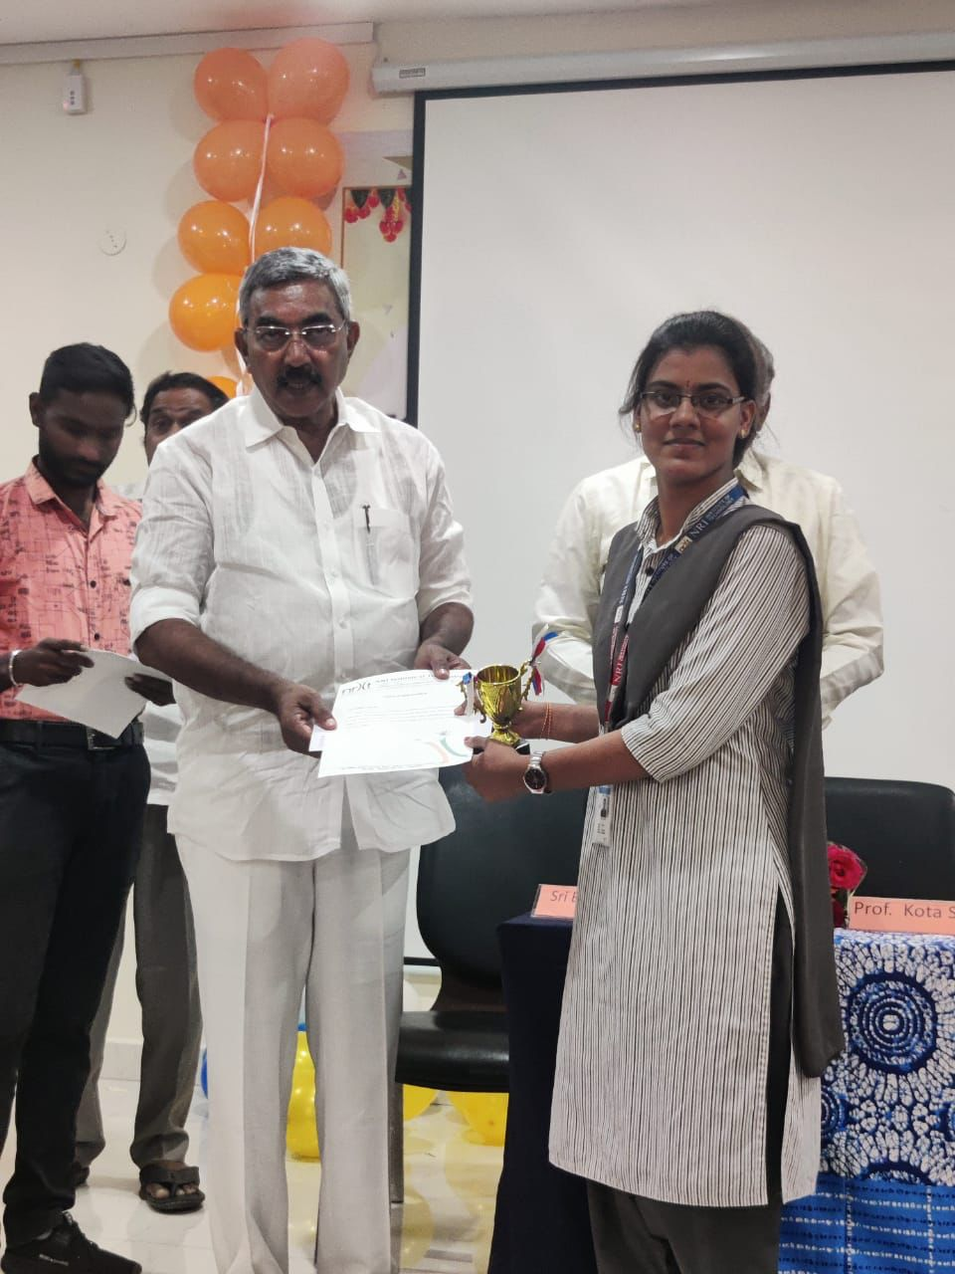

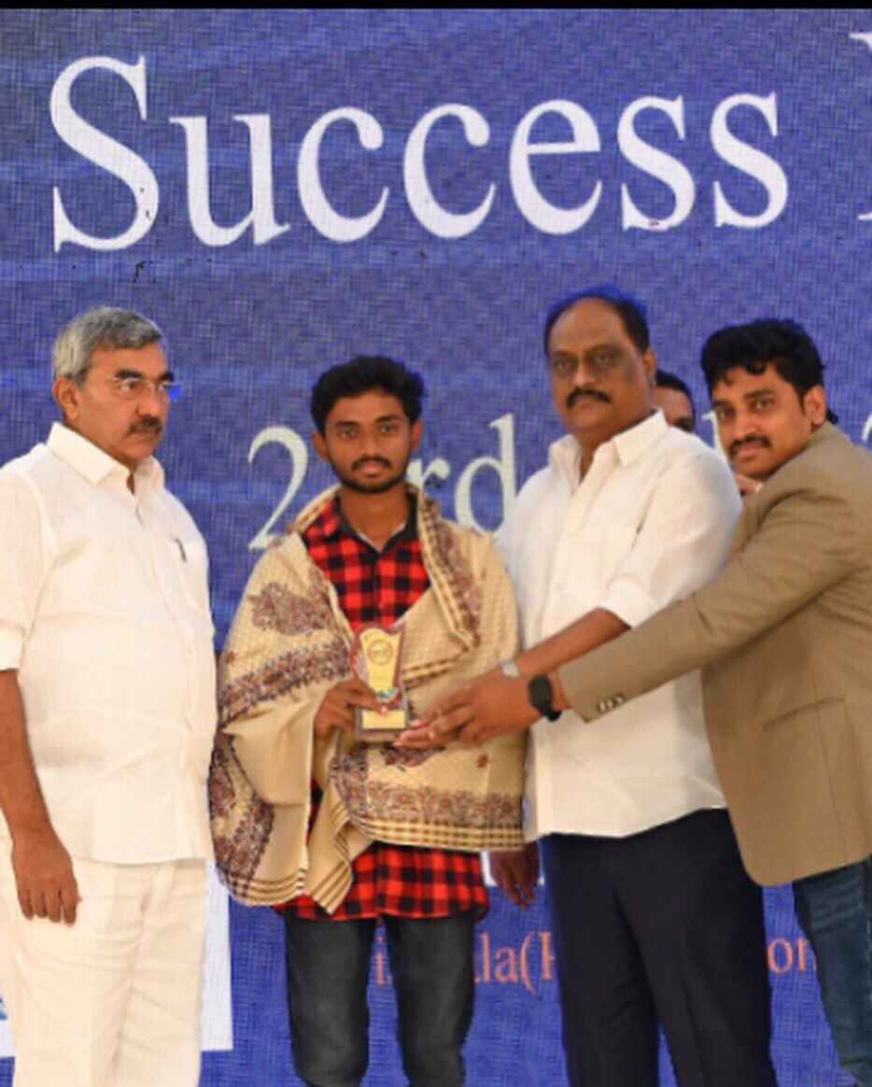

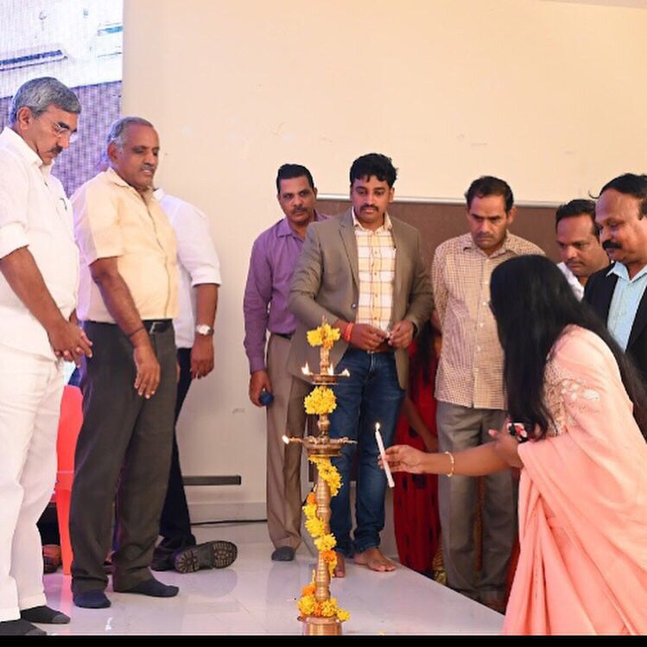

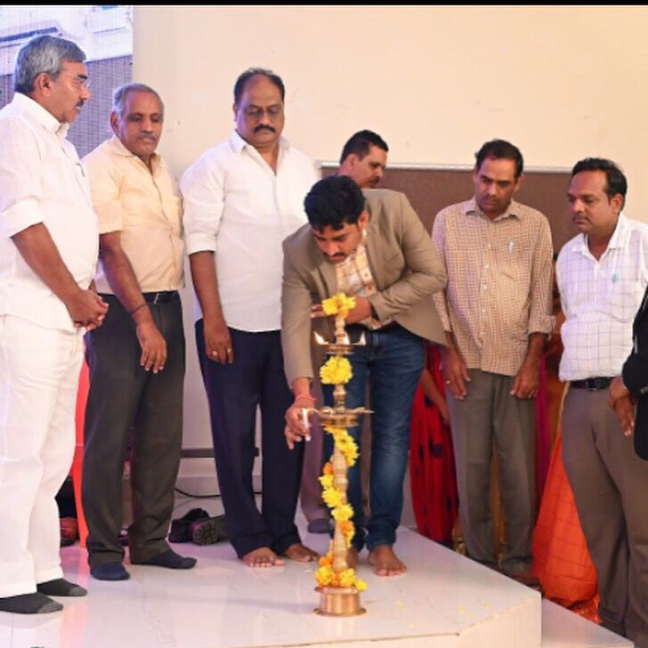

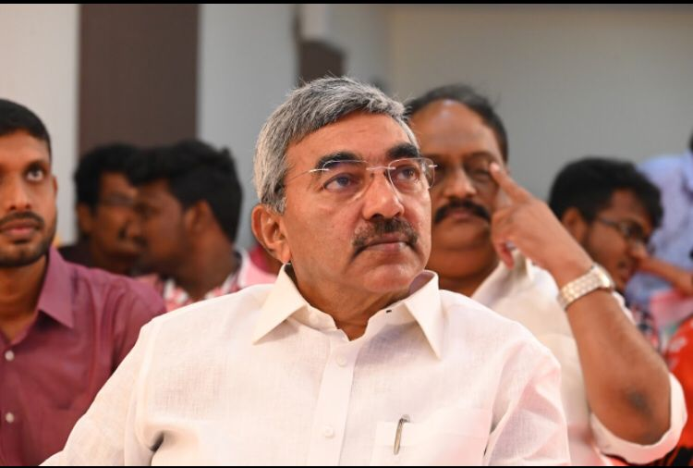

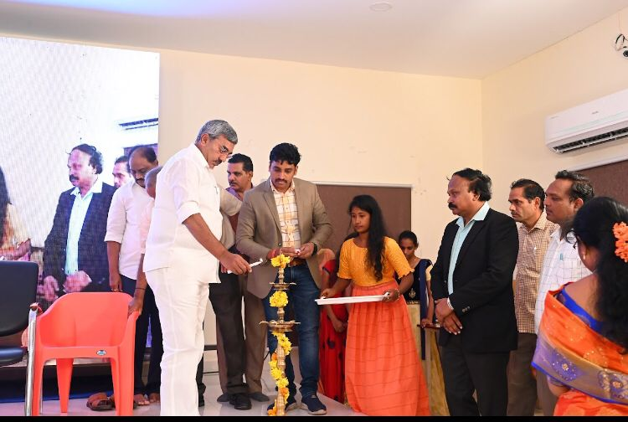

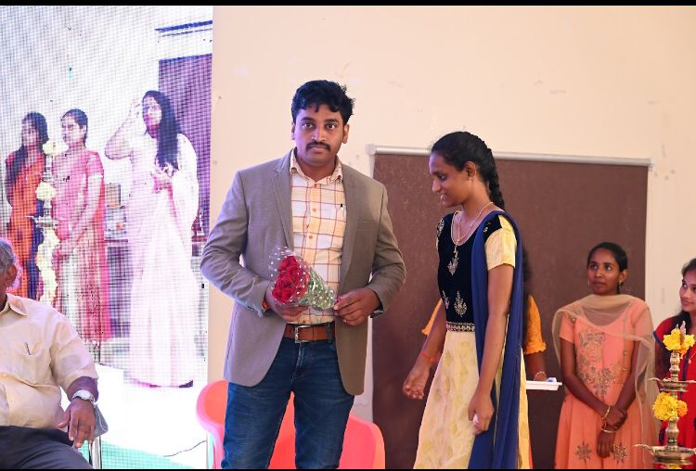

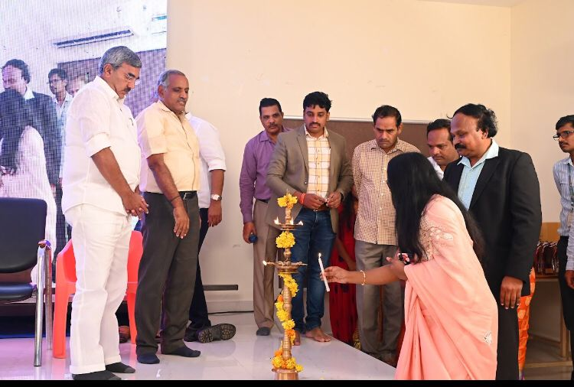

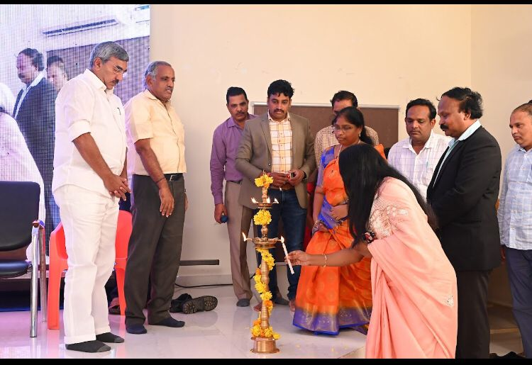

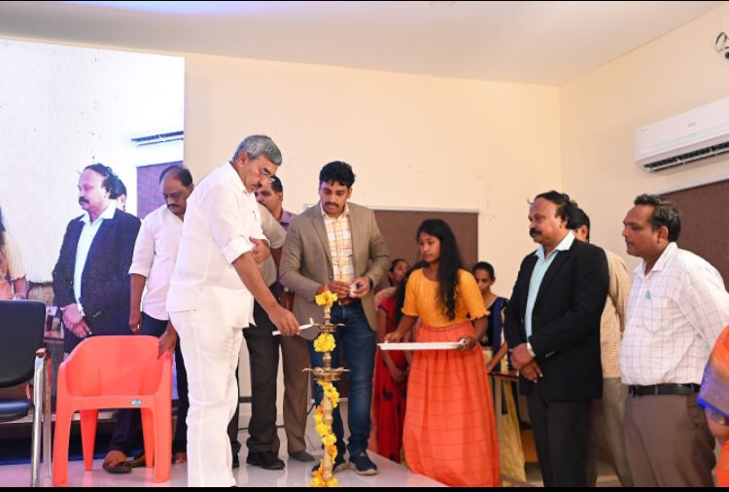

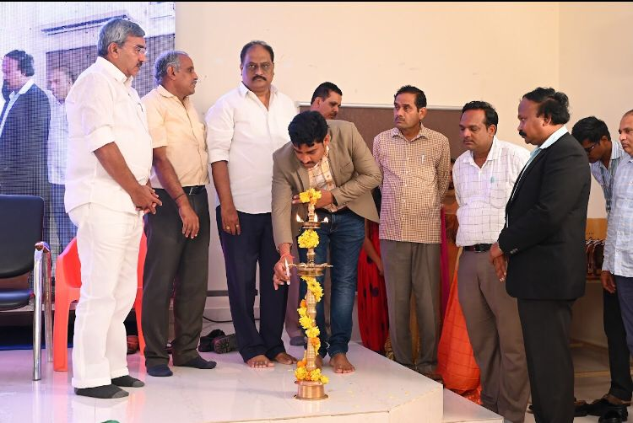

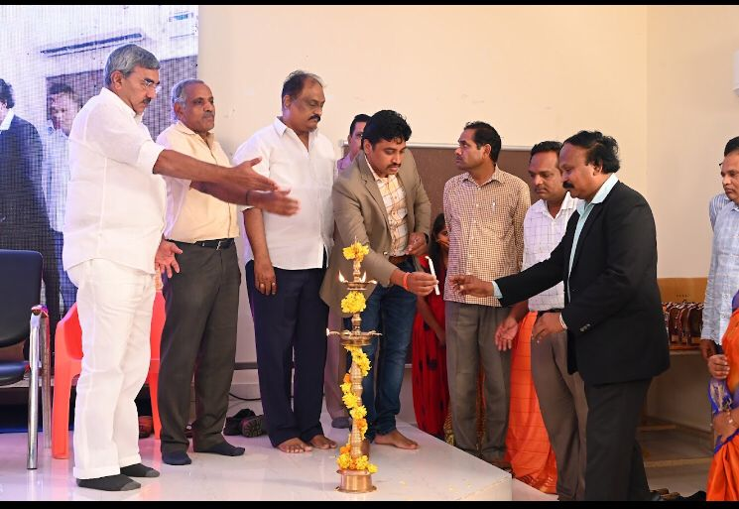

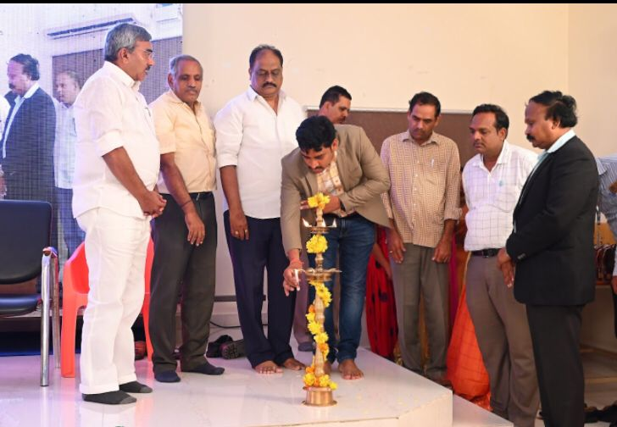

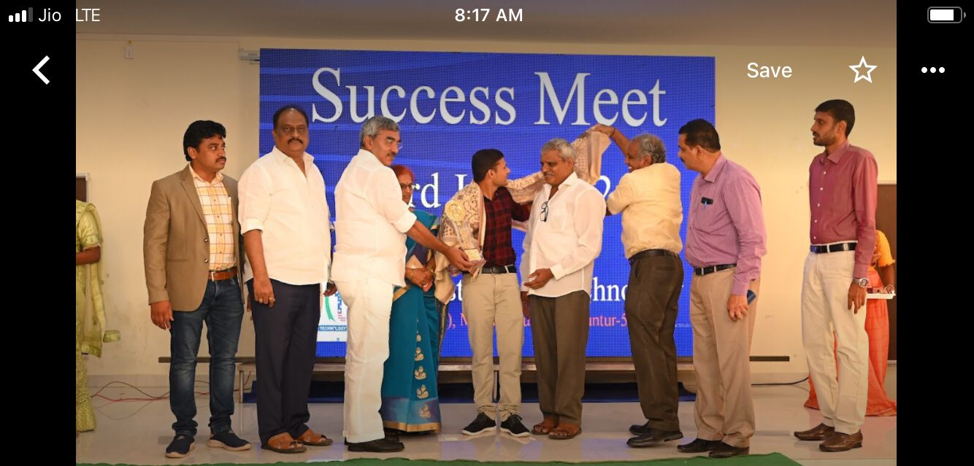

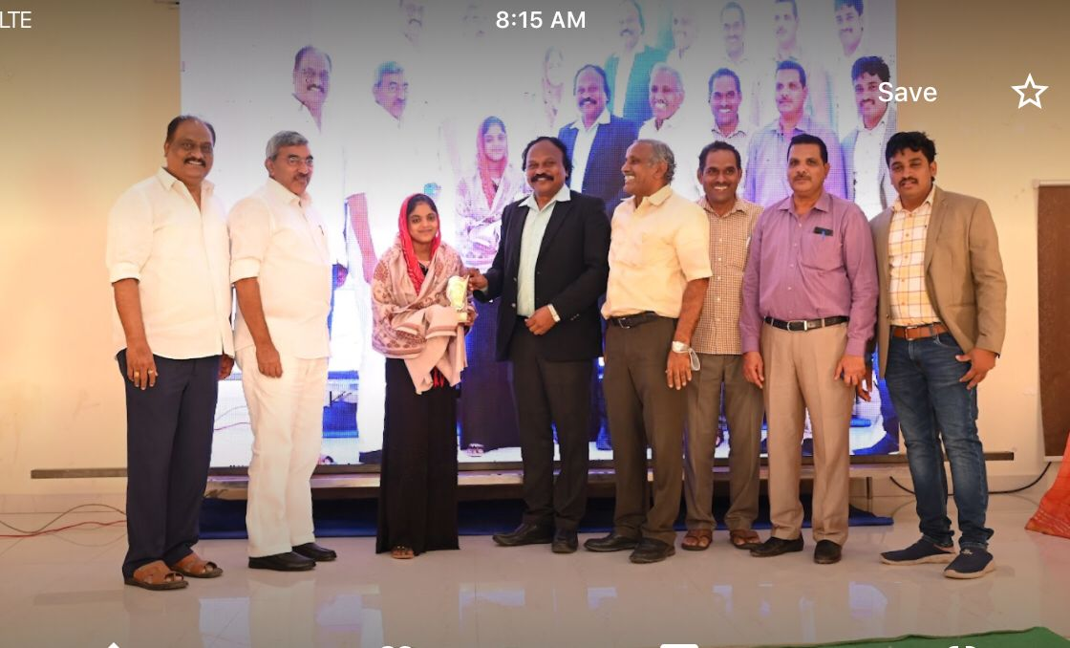

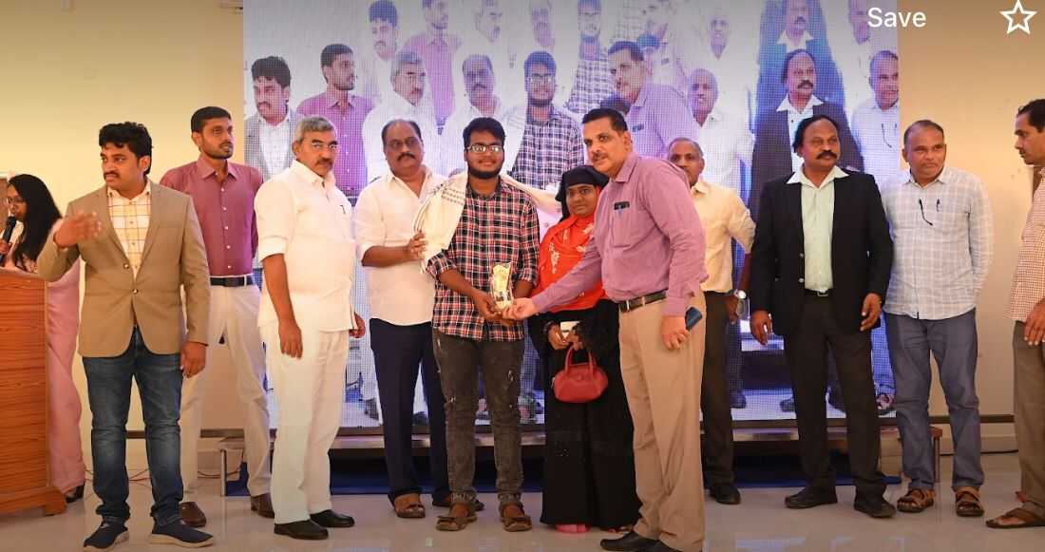

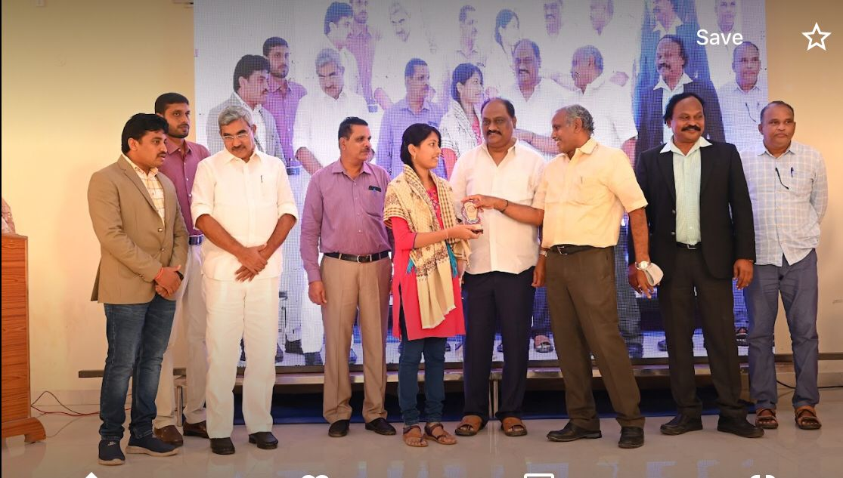

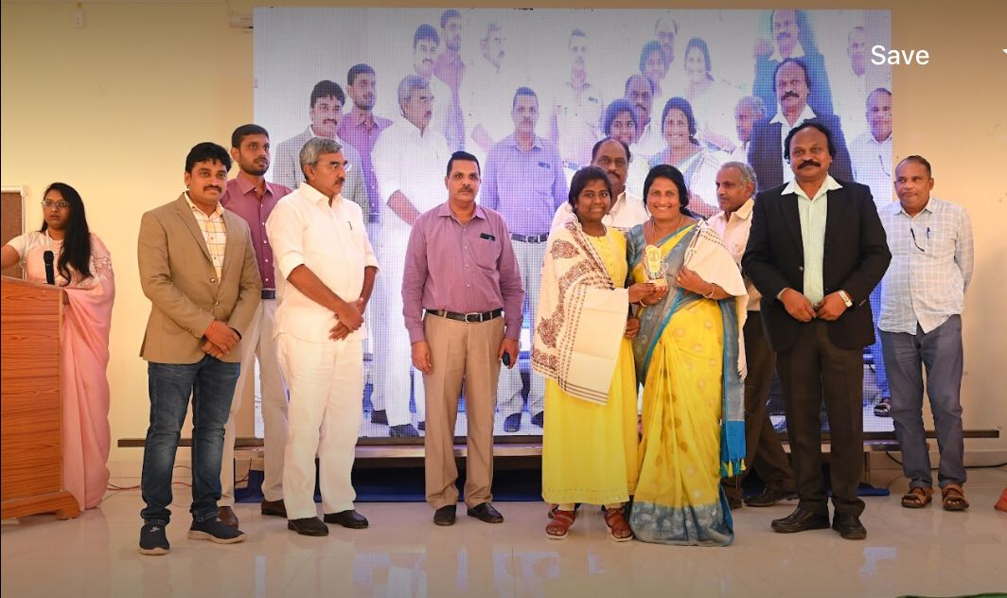

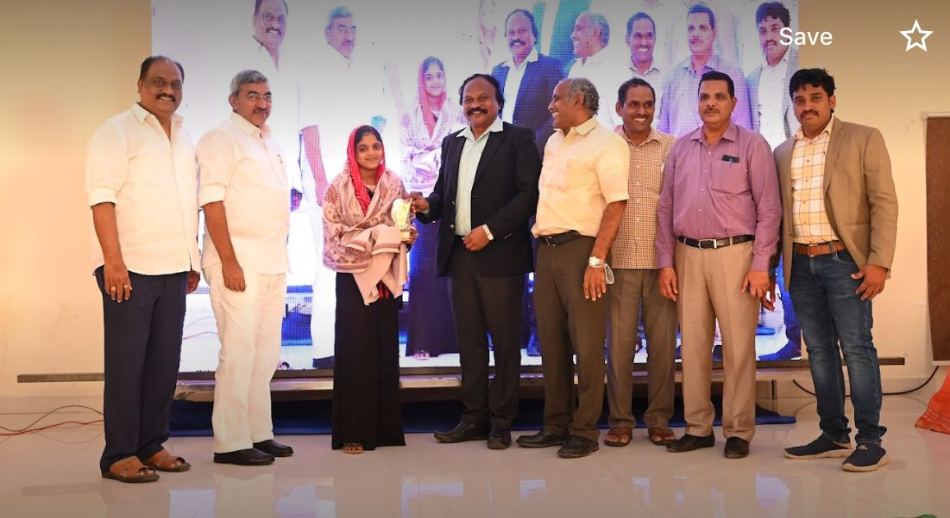







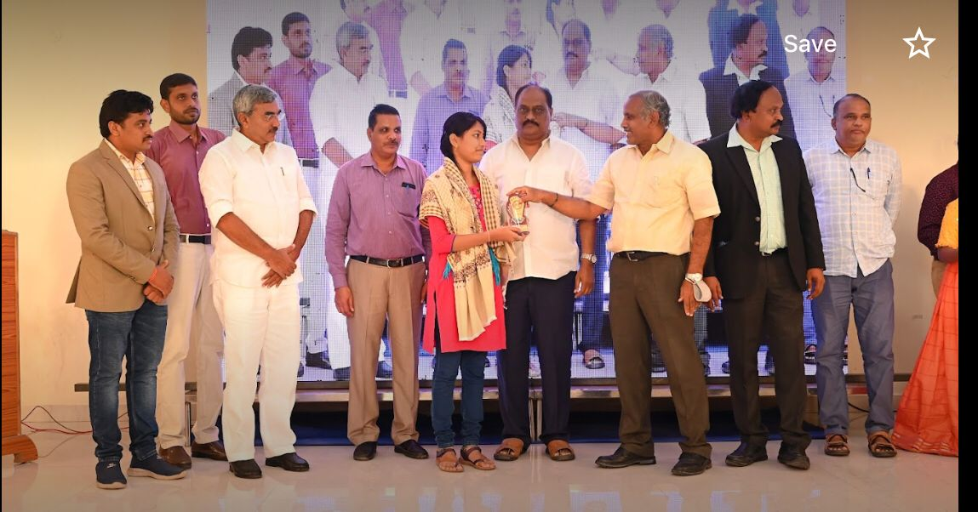

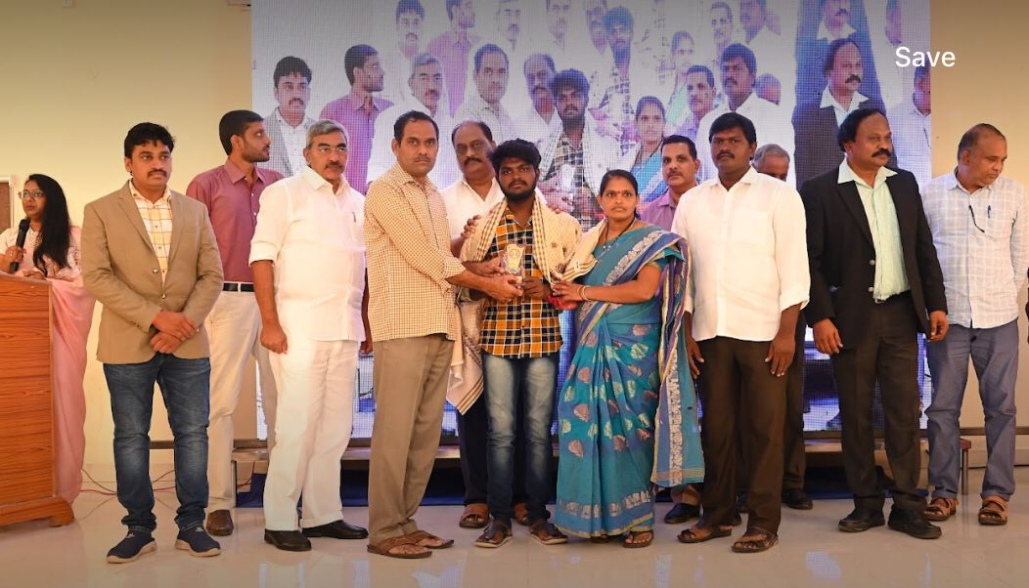

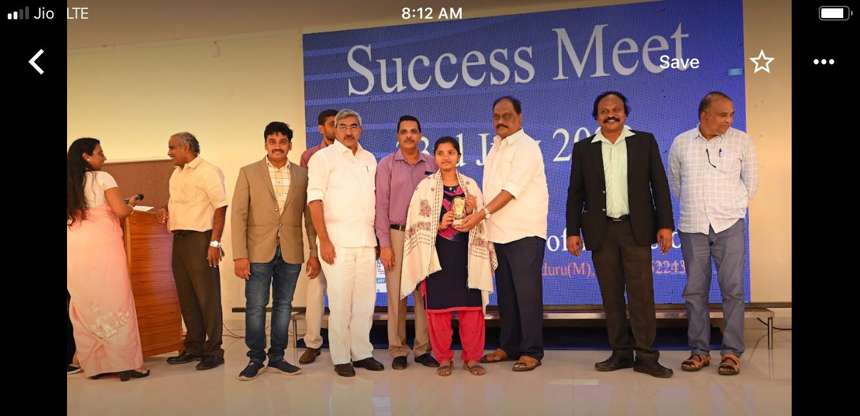



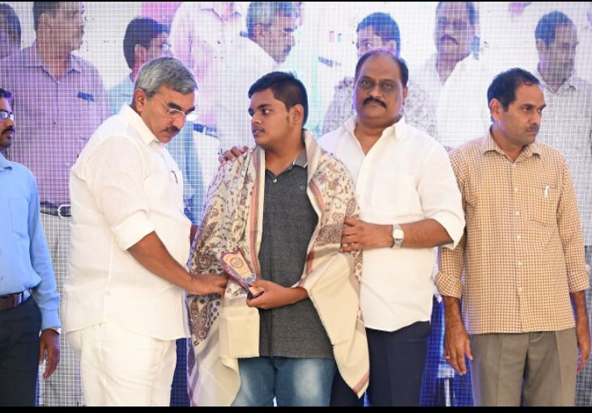

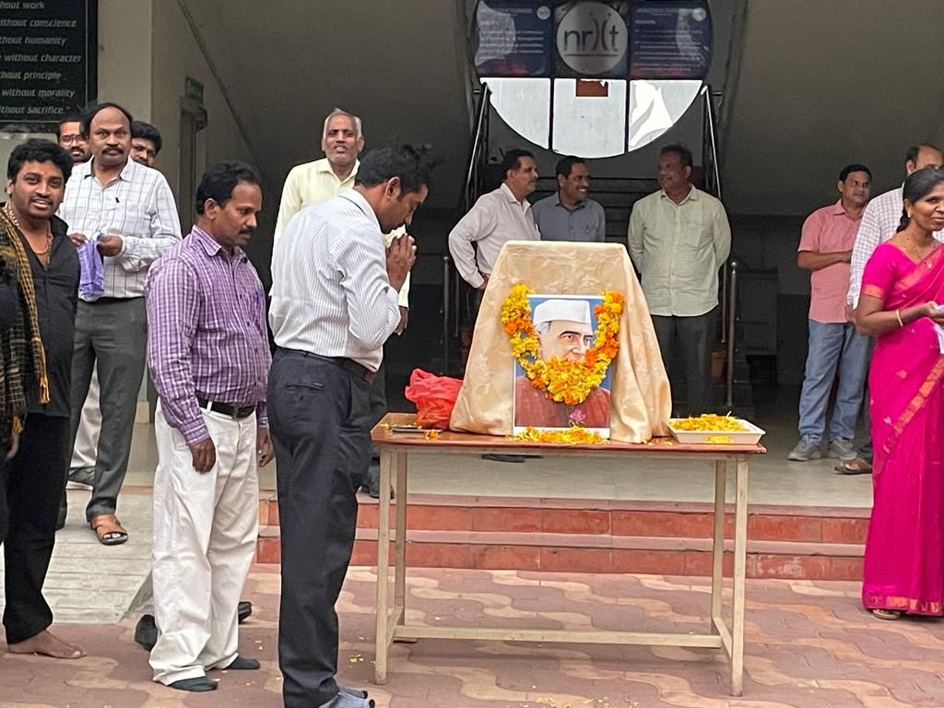

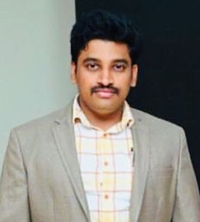

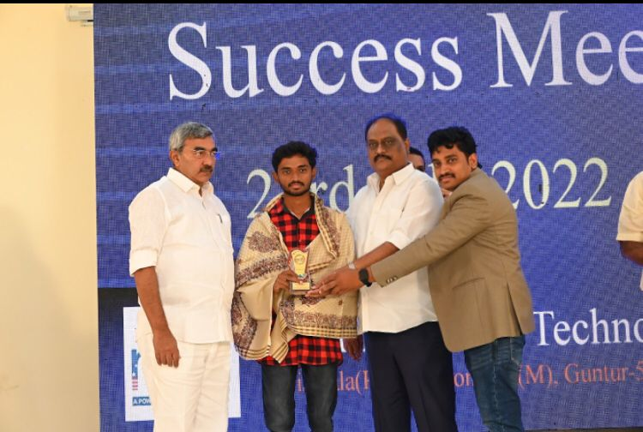

**INFORMATION**

**EDC CELL**

* [About EDC Cell](https://www.nriit.ac.in/edc_about)
* EDC STARTUP INDIA
* Entrepreneurship is widely acknowledged as a vital engine of a country's economic success. Even the Indian government recognizes the value of entrepreneurship and has implemented initiatives such as "Make in India" and "Start-up India."
* The Entrepreneurship Development Cell (EDC) of the NRI Institute of Technology (NRIIT) seeks to foster and promote entrepreneurial abilities among aspiring professionals interested in launching their own businesses. The institution provides infrastructural and technical assistance to students who have unique ideas for new goods and services that will benefit society. All hopefuls are also assisted by the EDC with coaching, planning, and execution of their start-up idea into an actual business. The EDC has a pool of sponsors, including banks, national entrepreneurship training organizations, and suppliers, who are eager to assist aspiring entrepreneurs.
* As a result, an Entrepreneurship Development Cell was founded in the college, with a dedicated team of actively working faculty with professional experience, as well as some student representatives. Aspiring engineer entrepreneurs are given the required inputs on how to be a successful entrepreneur through workshops and seminars conducted by experts in the field. We encourage students to consider self-employment as a career option at NRIIT, and we offer the essential training in entrepreneurship skills through structured courses. The cell also organizes various activities and events on a regular basis to train and motivate students regarding entrepreneurship.
* **VISION**
* Our goal is to enable our society develop by empowering entrepreneurs with integrity and sustainability, as well as supporting individual aptitude and innovation.
* **MISSION**
* To be the leader in enabling and aiding entrepreneurs, to encourage the sparks of emerging entrepreneurs, and to manifest the passion and energy of young students from invention to start-up to establishment and scaling up with integrity and sustainability through various programs and schemes.
* **OBJECTIVES**
* 1. To forge an alliance between the parent institution, industries, and R&D institutions in the region, as well as other organizations involved in the promotion of small and medium enterprises (SMEs), such as NGOs and other voluntary organizations.  
  2. To raise entrepreneurial awareness among students.  
  3. To instill an entrepreneurial mindset and culture among engineering graduates and postgraduates.  
  4. To provide industries with need-based consulting services.  
  5. To successfully address the possibilities and difficulties that SMEs and microenterprises are facing.
* **FUNCTIONS**
* 1. To organize entrepreneurship awareness camps, entrepreneurship development programs, and faculty development programs in the region for the benefit of S&T persons.  
  2. To develop and introduce curriculum on entrepreneurial development at various levels, including degree and diploma courses at the parent institution and other institutes in the region.  
  3. To conduct research work and survey for identifying entrepreneurial opportunities  
  4. To guide and assist prospective entrepreneurs on various aspects such as preparing project reports, obtaining project approvals, loans and facilities from agencies of support systems and information on various technologies  
  5. To organize guest lectures, Seminars, etc. for promotion and growth of S& T based entrepreneurship.  
  6. To arrange visits to industries for prospective entrepreneurs.  
  7. To extend necessary guidance and escort services to the trainees in obtaining approval and execution of their projects.  
  8. To act as a Regional Information Centre on business opportunities, processes, technologies, market, etc. by creating and maintaining relevant databases.  
  9. To provide testing, calibration, quality assurance, design, tool room, pilot plant and other facilities for Entrepreneurs besides expertise in Intellectual Property rights, Patents search, etc.  
  10. To render advice to sick enterprises and assist the entrepreneurs in rehabilitating them.

Innovation & Startup Policy

Entrepreneurs List

Top 10 Entrepreneurs

|  |  |  |  |  |  |  |
| --- | --- | --- | --- | --- | --- | --- |
| S.NO | ROLL NO. | NAME OF THE STUDENT | BRANCH | NAME OF THE BUSINESS &ADDRESS | YEAR / BATCH | Location |

EDC Events

|  |  |  |  |
| --- | --- | --- | --- |
| S.NO | Academic Year | Name of the Event | Date |

Startup India

Steps To Starting a Business

EDC STEPS TO STARTING A BUSINESS

Starting a business involves planning, making key financial decisions and completing a series of legal activities. These 10 easy steps can help you plan, prepare and manage your business. Click on the links to learn more.

STEP 1: WRITE A BUSINESS PLAN

Use these tools and resources to create a business plan. This written guide will help you map out how you will start and run your business successfully.

Define your vision: What will be the end result of your business?  
Define your mission: Different to a vision, your mission should explain the reason your company exists.  
Define your objectives: What are you going to do -- what are your goals -- that will lead to the accomplishment of your mission and your vision?  
Outline your basic strategies: How are you going to achieve the objectives you just bulleted?  
Write a simple action plan: Bullet out the smaller task-oriented actions required to achieve the stated objectives.

STEP 2: GET BUSINESS ASSISTANCE AND TRAINING

Take advantage of free training and counselling services, from preparing a business plan and securing financing, to expanding or relocating a business.

STEP 3: CHOOSE A BUSINESS LOCATION

Get advice on how to select a customer-friendly location and comply with zoning laws.

STEP 4: FINANCE YOUR BUSINESS

Find government backed loans, venture capital and research grants to help you get started.

STEP 5: DETERMINE THE LEGAL STRUCTURE OF YOUR BUSINESS

Decide which form of ownership is best for you: sole proprietorship, partnership, Limited Liability Company (LLC), corporation, S corporation, non-profit or cooperative.

STEP 6: REGISTER A BUSINESS NAME ("DOING BUSINESS AS")

Register your business name with your state government. Learn which tax identification number you'll need to obtain from the IRS and your state revenue agency.

STEP 7: REGISTER FOR STATE AND LOCAL TAXES

Register with your state to obtain a tax identification number, workers' compensation, unemployment and disability insurance.

STEP 8: OBTAIN BUSINESS LICENSES AND PERMITS

Get a list of federal, state and local licenses and permits required for your business.

STEP 9: UNDERSTAND EMPLOYER RESPONSIBILITIES

Learn the legal steps you need to take to hire employees.

STEP 10: FIND LOCAL ASSISTANCE

Contact your local SBA office to learn more about how SBA can help.

NRI IT INNOVATION

NRI IT INNOVATION

This form is designed to capture the initial details of your idea/innovation/IPR developed at NRI Institute of Technology, ITIC. Information provided will be treated strictly confidential and only be used by Incubation Ceter to assess the stage you are at in order to be considered for incubation. In order to assist NRIIT, ITIC with this assessment please complete the form as fully as possible.

1) IDEA/INNOVATION

Title of the proposed idea/innovation/invention:

2) DESCRIPTION OF IDEA

Brief write-up (max. 1000 words) with broad details of the original idea/ invention/ IPR/ know-how available with the individual(s), highlighting its originality/novelty and the scientific principle involved, addressing:

a) Background (why the technology is required)  
b) Description (how, in laymen terms, the technology works)  
c) Advantages (what the technology does, over and above existing methods)  
d) Do you know any Mentor who is capable of offering guidance to your idea/concept and also to other batches? If yes, please furnish details.

DETAILS OF SUPPORT SOUGHT FROM NRIIT, ITIC

Details of proposed project (attach Business plan, if applicable)  
(a) Objectives  
(b) Core team members and their respective roles  
(c) Mentors/advisors  
(d) Duration/time schedule  
(e) Major activities to be undertaken for the next one year (e.g., design, prototyping, field trial, demonstration, consultancy, etc)  
(f) Proposed costs and time frame (indicate investment requirements for first one year of operations)  
(g) How will you promote/advertise your products/services

3.2 Facilities required from NRIIT, ITIC (please list)

Try to address points on infrastructure requirement for space, any special requirements for usage of lab facilities, requirement of professional services/support.

3.3 Any other information relevant to the project that you wish to communicate with us.

4) APPLICANTS’ DETAILS

Name and attach a brief CV (maximum 1 page)of (all)person(s) associated with the project. (Provide complete contact address with phone and email)

You can send the filled in **APPLICATION to nriitstartup@gmail.com**

**AICTE**

**2022-23 AICTE APPROVAL LETTER**

All India Council for Technical Education

**(A Statutory body under Ministry of Education, Govt. of India)**

Nelson Mandela Marg,Vasant Kunj, New Delhi-110070 Website: [www.aicte-india.org](http://www.aicte-india.org/)

**APPROVAL PROCESS 2022-23**

***-***

**Extension of Approval (EoA)**

F.No. South-Central/1-10974902104/2022/EOA Date: 07-Jul-2022

To,

The Principal Secretary

(Higher Education) Govt. of Andhra Pradesh, J Block, 4th Floor, Secretariat Building, Hyderabad-500022

**Sub: Extension of Approval for the Academic Year 2022-23**

Ref: Application of the Institution for Extension of Approval for the Academic Year 2022-23 Sir/Madam,

In terms of the provisions under the All India Council for Technical Education (Grant of Approvals for Technical Institutions) Regulations, 2022 Notified on 4th February, 2022 and amended on 24th February 2022 and norms standards, procedures and conditions prescribed by the Council from time to time, I am directed to convey the approval to

|  |  |  |  |
| --- | --- | --- | --- |
| **Permanent Id** | 1-6140036 | **Application Id** | 1-10974902104 |
| **Name of the Institution** | NRI INSTITUTE OF TECHNOLOGY | **Name of the Society/Trust** | MNK EDUCATIONAL SOCIETY |
| **Institution Address** | VISADALA (PO) MEDIKONDURU(MD) GUNTUR-522438  ANDHRA PRADESH, GUNTUR,  GUNTUR, Andhra Pradesh, 522438 | **Society/Trust Address** | C/O NRI INSTITUTE OF TECHNOLOGY,VISADALA (PO),MEDIKONDURU (MD),GUNTUR,GUNTUR,Andhra  Pradesh,522438 |
| **Institution Type** | Private-Self Financing | **Region** | South-Central |
| **Year of Establishment** | 2008 | | |

|  |  |  |  |
| --- | --- | --- | --- |
| **Opted for Introduction of New Program/Level** | Yes | **Introduction of Program/Level Approved or Not** | Approved |

**To conduct following Courses with the Intake indicated below for the Academic Year 2022-23**

|  |  |  |  |  |  |  |  |
| --- | --- | --- | --- | --- | --- | --- | --- |
| **Level** | **Program** | **Course** | **Affiliating Body (University**  **/Body)** | **Intake Approved for 2021-22** | **Intake Approved for 2022-23** | **NRI**  **Approval Status** | **FN / Gulf quota/ OCI/ Approval Status** |
| DIPLOMA | ENGINEERI NG AND TECHNOLO GY | ARTIFICIAL INTELLIGENCE (AI) AND MACHINE LEARNING | State Board of Technical Education and Training, Andhra Pradesh | 0 | 120## | NA | NA |
| DIPLOMA | ENGINEERI NG AND TECHNOLO GY | COMPUTER ENGINEERING | State Board of Technical Education and Training, Andhra Pradesh | 0 | 120## | NA | NA |

|  |  |  |  |  |  |  |  |
| --- | --- | --- | --- | --- | --- | --- | --- |
| **Level** | **Program** | **Course** | **Affiliating Body (University**  **/Body)** | **Intake Approved for 2021-22** | **Intake Approved for 2022-23** | **NRI**  **Approval Status** | **FN / Gulf quota/ OCI/ Approval Status** |
| DIPLOMA | ENGINEERI NG AND TECHNOLO GY | ELECTRONICS AND COMMUNICATIO N ENGINEERING | State Board of Technical Education and Training, Andhra Pradesh | 0 | 60## | NA | NA |
| UNDER GRADUATE | ENGINEERI NG AND TECHNOLO GY | ARTIFICIAL INTELLIGENCE AND MACHINE LEARNING | Jawaharlal Nehru Technological University, Kakinada | 60 | 60 | NA | NA |
| UNDER GRADUATE | ENGINEERI NG AND TECHNOLO GY | CIVIL ENGINEERING | Jawaharlal Nehru Technological University, Kakinada | 60 | 30 | NA | NA |
| UNDER GRADUATE | ENGINEERI NG AND TECHNOLO GY | COMPUTER SCIENCE AND ENGINEERING | Jawaharlal Nehru Technological University, Kakinada | 120 | 150 | NA | NA |
| UNDER GRADUATE | ENGINEERI NG AND TECHNOLO GY | COMPUTER SCIENCE AND ENGINEERING (DATA SCIENCE) | Jawaharlal Nehru Technological University, Kakinada | 120 | 180 | NA | NA |
| UNDER GRADUATE | ENGINEERI NG AND TECHNOLO GY | ELECTRONICS & COMMUNICATIO N ENGG | Jawaharlal Nehru Technological University, Kakinada | 180 | 120 | NA | NA |
| UNDER GRADUATE | ENGINEERI NG AND TECHNOLO GY | INFORMATION TECHNOLOGY | Jawaharlal Nehru Technological University, Kakinada | 60 | 60 | NA | NA |
| POST GRADUATE | ENGINEERI NG AND TECHNOLO GY | STRUCTURAL ENGINEERING | Jawaharlal Nehru Technological University, Kakinada | 18 | 18 | NA | NA |
| POST GRADUATE | MANAGEM ENT | MBA | Jawaharlal Nehru Technological University, Kakinada | 120 | 120 | NA | NA |
| POST GRADUATE | ENGINEERI NG AND TECHNOLO GY | COMPUTER SCIENCE AND ENGINEERING | Jawaharlal Nehru Technological University, Kakinada | 18 | 18 | NA | NA |
| POST GRADUATE | ENGINEERI NG AND TECHNOLO GY | DIGITAL ELECTRONICS AND COMMUNICATIO N SYSTEMS | Jawaharlal Nehru Technological University, Kakinada | 18 | 18 | NA | NA |

|  |  |  |  |  |  |  |  |
| --- | --- | --- | --- | --- | --- | --- | --- |
| **Level** | **Program** | **Course** | **Affiliating Body (University**  **/Body)** | **Intake Approved for 2021-22** | **Intake Approved for 2022-23** | **NRI**  **Approval Status** | **FN / Gulf quota/ OCI/ Approval Status** |

## Approved New Course(s)

**It is mandatory to comply with all the essential requirements as given in APH 2022-23 (Appendix 6)**

|  |
| --- |
|  |
|  |  |

**Pharmacy Institute:** In compliance with the order dated 05.03.2020 passed by the Hon'ble Supreme Court of India in Transferred Petitions (CIVIL) No 87-101 of 2014, for the existing institutions offering courses in Pharmacy Programme, approval of Pharmacy Council of India (PCI) is mandatory and AICTE approval is NOT required. The requirements for running the Programme (Diploma / UG / PG) such as Land & Build-up Area, Student-faculty ratio, Intake etc. will be as per the respective regulatory body (PCI).

In case of any inconsistency in the course name and intake for EoA issued by AICTE and the approval by PCI, the approval of PCI shall prevail.

**Architecture Institute:** In compliance with the order dated 08.11.2019 passed by the Hon'ble Supreme Court of Indian CA No.364/ 2005, for the existing Institutions offering Courses in Architecture Programme, approval by the Council of Architecture (CoA) is mandatory and AICTE approval is NOT required. The requirements for running the Programme (Diploma / UG / PG) such as Land & Build-up Area, Student-faculty ratio, Intake etc. will be as per respective regulatory body (CoA). In case of any inconsistency in the course name and intake for EoA issued by AICTE and the approval by CoA, the approval of CoA shall prevail.

**Deemed to be University:** Institutions Deemed to be Universities (Running Technical Education Programmes), it is mandatory to have AICTE approval from the Academic Year 2018-19 in compliance of the Hon'ble Supreme Court Order dated 03-11-2017 passed in CA No.17869- 17870 /2017.

**Prof.Rajive Kumar Member Secretary, AICTE**

Copy to:

1. **The Director Of Technical Education**, Andhra Pradesh**
2. **The Registrar**,**

Jawaharlal Nehru Technological University, Kakinada

1. **The Principal / Director,**

NRI INSTITUTE OF TECHNOLOGY

Visadala (Po) Medikonduru(Md) Guntur-522438 Andhra Pradesh, Guntur,Guntur,

Andhra Pradesh,522438

1. **The Secretary / Chairman,**

C/O NRI INSTITUTE OF TECHNOLOGY,VISADALA (PO),MEDIKONDURU (MD) GUNTUR,GUNTUR

Andhra Pradesh,522438

1. **The Regional Officer,**

All India Council for Technical Education First Floor, old BICARD Building Jawaharlal Nehru Technological University Masab Tank, Hyderabad-500076

1. **Guard File(AICTE)**

Note: Validity of the Course details may be verified at <http://www.aicte-india.org/>

|  |
| --- |
|  |
|  |  |

**\*\*** Individual Approval letter copy will not be communicated through Post/Email. However, consolidated list of Approved Institutions(bulk) will be shared through official Email Address to the concerned Authorities mentioned above.

*This is a computer generated Statement. No signature Required*

**2021-22 AICTE APPROVAL LETTER**

**All India Council for Technical Education**

**(A Statutory body under Ministry of Education, Govt. of India)**

**Nelson Mandela Marg,Vasant Kunj, New Delhi-110070 Website:** [www.aicte-india.org](http://www.aicte-india.org/)

**APPROVAL PROCESS 2021-22**

***-***

**Extension of Approval (EoA)**

**F.No. South-Central/1-9318872645/2021/EOA Date: 30-Jun-2021**

**To,**

**The Principal Secretary**

**(Higher Education) Govt. of Andhra Pradesh, J Block, 4th Floor, Secretariat Building, Hyderabad-500022**

**Sub: Extension of Approval for the Academic Year 2021-22**

**Ref: Application of the Institution for Extension of Approval for the Academic Year 2021-22 Sir/Madam,**

**In terms of the provisions under the All India Council for Technical Education (Grant of Approvals for Technical Education) (1st Amendment) Regulations, 2021 notified on 24th February 2021 and other notifications as applicable and published from time to time, I am directed to convey the approval to**

|  |  |  |  |
| --- | --- | --- | --- |
| **Permanent Id** | **1-6140036** | **Application Id** | **1-9318872645** |
| **Name of the Institution**  **/University** | **NRI INSTITUTE OF TECHNOLOGY** | **Name of the Society/Trust** | **MNK EDUCATIONAL SOCIETY** |
| **Institution /University Address** | **VISADALA (PO) MEDIKONDURU(MD) GUNTUR-522438**  **ANDHRA PRADESH, GUNTUR,**  **GUNTUR, Andhra Pradesh, 522438** | **Society/Trust Address** | **C/O NRI INSTITUTE OF TECHNOLOGY,VISADALA (PO),MEDIKONDURU (MD),GUNTUR,GUNTUR,Andhra**  **Pradesh,522438** |
| **Institution /University Type** | **Private-Self Financing** | **Region** | **South-Central** |

**To conduct following Programs / Courses with the Intake indicated below for the Academic Year 2021-22**

|  |  |  |  |  |  |  |  |
| --- | --- | --- | --- | --- | --- | --- | --- |
| **Program** | **Level** | **Course** | **Affiliating Body (University /Body)** | **Intake Approved for 2020-21** | **Intake Approved for 2021-22** | **NRI**  **Approval Status** | **FN / Gulf quota/ OCI/ Approval Status** |
| **ENGINEERING AND TECHNOLOGY** | **POST GRADUATE** | **STRUCTURAL ENGINEERING** | **Jawaharlal Nehru Technological University, Kakinada** | **18** | **18** | **NA** | **NA** |
| **ENGINEERING AND TECHNOLOGY** | **UNDER GRADUATE** | **COMPUTER SCEINCE & ENGINEERING** | **Jawaharlal Nehru Technological University, Kakinada** | **120** | **120** | **NA** | **NA** |
| **ENGINEERING AND TECHNOLOGY** | **UNDER GRADUATE** | **ELECTRONICS & COMMUNICATIO N ENGG** | **Jawaharlal Nehru Technological University, Kakinada** | **180** | **180** | **NA** | **NA** |

|  |  |  |  |  |  |  |  |
| --- | --- | --- | --- | --- | --- | --- | --- |
| **ENGINEERING AND TECHNOLOGY** | **UNDER GRADUATE** | **CIVIL ENGINEERING** | **Jawaharlal Nehru Technological University, Kakinada** | **90** | **60** | **NA** | **NA** |
| **MANAGEMENT** | **POST GRADUATE** | **MBA** | **Jawaharlal Nehru Technological University, Kakinada** | **120** | **120** | **NA** | **NA** |
| **ENGINEERING AND TECHNOLOGY** | **POST GRADUATE** | **COMPUTER SCIENCE AND ENGINEERING** | **Jawaharlal Nehru Technological University, Kakinada** | **36** | **18** | **NA** | **NA** |
| **ENGINEERING AND TECHNOLOGY** | **POST GRADUATE** | **DIGITAL ELECTRONICS AND COMMUNICATIO N SYSTEMS** | **Jawaharlal Nehru Technological University, Kakinada** | **18** | **18** | **NA** | **NA** |
| **ENGINEERING AND TECHNOLOGY** | **UNDER GRADUATE** | **INFORMATION TECHNOLOGY** | **Jawaharlal Nehru Technological University, Kakinada** | **60** | **60** | **NA** | **NA** |
| **ENGINEERING AND TECHNOLOGY** | **UNDER GRADUATE** | **COMPUTER SCIENCE AND ENGINEERING (DATA SCIENCE)** | **Jawaharlal Nehru Technological University, Kakinada** | **60** | **120** | **NA** | **NA** |
| **ENGINEERING AND TECHNOLOGY** | **UNDER GRADUATE** | **ARTIFICIAL INTELLIGENCE AND MACHINE LEARNING** | **Jawaharlal Nehru Technological University, Kakinada** | **0** | **60##** | **NA** | **NA** |

**## Approved New Course(s)**

**Course(s) Applied for Closure by the Institution for the Academic Year 2021-22**

|  |  |  |  |  |
| --- | --- | --- | --- | --- |
| **Program** | **Level** | **Course** | **Affiliating Body (Univ/Body)** | **Course Closure Status** |
| **ENGINEERING**  **AND TECHNOLOGY** | **UNDER GRADUATE** | **MECHANICAL ENGINEERING** | **Jawaharlal Nehru Technological University, Kakinada** | **Approved** |
| **ENGINEERING**  **AND TECHNOLOGY** | **UNDER GRADUATE** | **ELECTRICAL AND ELECTRONICS ENGINEERING** | **Jawaharlal Nehru Technological University, Kakinada** | **Approved** |

**It is mandatory to comply with all the essential requirements as given in APH 2021-22 (Appendix 6)**

|  |
| --- |
|  |
|  |  |

**2020-21 AICTE APPROVAL LETTER**

**All India Council for Technical Education**

**(A Statutory body under Ministry of HRD, Govt. of India)**

**Nelson Mandela Marg,Vasant Kunj, New Delhi-110070 Website:** [www.aicte-india.org](http://www.aicte-india.org/)

**APPROVAL PROCESS 2020-21**

***-***

**Extension of Approval (EoA)**

**F.No. South-Central/1-7008123950/2020/EOA Date: 15-Jun-2020**

**To,**

**The Principal Secretary**

**(Higher Education) Govt. of Andhra Pradesh, J Block, 4th Floor, Secretariat Building, Hyderabad-500022**

**Sub: Extension of Approval for the Academic Year 2020-21**

**Ref: Application of the Institution for Extension of Approval for the Academic Year 2020-21 Sir/Madam,**

**In terms of the provisions under the All India Council for Technical Education (Grant of Approvals for Technical Institutions) Regulations 2020 notified by the Council vide notification number F.No. AB/AICTE/REG/2020 dated 4th February 2020 and norms standards, procedures and conditions prescribed by the Council from time to time, I am directed to convey the approval to**

|  |  |  |  |
| --- | --- | --- | --- |
| **Permanent Id** | **1-6140036** | **Application Id** | **1-7008123950** |
| **Name of the Institution** | **NRI INSTITUTE OF TECHNOLOGY** | **Name of the Society/Trust** | **MNK EDUCATIONAL SOCIETY** |
| **Institution Address** | **VISADALA (PO) MEDIKONDURU(MD) GUNTUR-522438**  **ANDHRA PRADESH, GUNTUR,**  **GUNTUR, Andhra Pradesh, 522438** | **Society/Trust Address** | **C/O NRI INSTITUTE OF TECHNOLOGY,VISADALA (PO),MEDIKONDURU (MD),GUNTUR,GUNTUR,Andhra**  **Pradesh,522438** |
| **Institution Type** | **Private-Self Financing** | **Region** | **South-Central** |

**To conduct following Courses with the Intake indicated below for the Academic Year 2020-21**

|  |  |  |  |  |  |  |  |
| --- | --- | --- | --- | --- | --- | --- | --- |
| **Program** | **Level** | **Course** | **Affiliating Body (University**  **/Body)** | **Intake Approved for 2019-20** | **Intake Approved for 2020-21** | **NRI**  **Approval Status** | **PIO / FN /**  **Gulf quota/ OCI/**  **Approval**  **Status** |
| **ENGINEERING AND TECHNOLOGY** | **POST GRADUATE** | **STRUCTURAL ENGINEERING** | **Jawaharlal Nehru Technological University, Kakinada** | **18** | **18** | **NA** | **NA** |
| **ENGINEERING AND TECHNOLOGY** | **UNDER GRADUATE** | **MECHANICAL ENGINEERING** | **Jawaharlal Nehru Technological University, Kakinada** | **120** | **60** | **NA** | **NA** |
| **ENGINEERING AND TECHNOLOGY** | **UNDER GRADUATE** | **COMPUTER SCEINCE & ENGINEERING** | **Jawaharlal Nehru Technological University, Kakinada** | **120** | **120** | **NA** | **NA** |

|  |  |  |  |  |  |  |  |
| --- | --- | --- | --- | --- | --- | --- | --- |
| **ENGINEERING AND TECHNOLOGY** | **UNDER GRADUATE** | **ELECTRONICS**  **& COMMUNICATIO N ENGG** | **Jawaharlal Nehru Technological University, Kakinada** | **180** | **180** | **NA** | **NA** |
| **ENGINEERING AND TECHNOLOGY** | **UNDER GRADUATE** | **CIVIL ENGINEERING** | **Jawaharlal Nehru Technological University, Kakinada** | **120** | **90** | **NA** | **NA** |
| **ENGINEERING AND TECHNOLOGY** | **UNDER GRADUATE** | **ELECTRICAL AND ELECTRONICS ENGINEERING** | **Jawaharlal Nehru Technological University, Kakinada** | **60** | **30** | **NA** | **NA** |
| **MANAGEMENT** | **POST GRADUATE** | **MBA** | **Jawaharlal Nehru Technological University, Kakinada** | **120** | **120** | **NA** | **NA** |
| **ENGINEERING AND TECHNOLOGY** | **POST GRADUATE** | **COMPUTER SCIENCE AND ENGINEERING** | **Jawaharlal Nehru Technological University, Kakinada** | **36** | **36** | **NA** | **NA** |
| **ENGINEERING AND TECHNOLOGY** | **POST GRADUATE** | **DIGITAL ELECTRONICS AND COMMUNICATIO N SYSTEMS** | **Jawaharlal Nehru Technological University, Kakinada** | **18** | **18** | **NA** | **NA** |
| **ENGINEERING AND TECHNOLOGY** | **UNDER GRADUATE** | **INFORMATION TECHNOLOGY** | **Jawaharlal Nehru Technological University, Kakinada** | **0** | **60##$$** | **NA** | **NA** |
| **ENGINEERING AND TECHNOLOGY** | **UNDER GRADUATE** | **COMPUTER SCIENCE AND ENGINEERING (DATA SCIENCE)** | **Jawaharlal Nehru Technological University, Kakinada** | **0** | **60##$$** | **NA** | **NA** |

**## Approved New Course(s)**

**$$ Course(s) should be offered in Emerging Area**

**It is mandatory to comply with all the essential requirements as given in APH 2020-21 (Appendix 6)**

**The Institution/ University is having the following deficiencies as per the online application submitted to AICTE and the same shall be complied within Six Months from the date of issue of this EoA**

|  |  |
| --- | --- |
| **Deficiencies Noted based on Self Disclosure** | |
| **Particulars** | **Deficiency** |

|  |  |
| --- | --- |
| **1. Other Facilities Deficiency** | |
| **Implementation of student Induction Programme** | **Yes** |
| **Waste Management and a sustainable Green Campus** | **Yes** |
| **2. Other Facilities III & Faculty Questions** | |

|  |  |
| --- | --- |
| **Fees to be charged, policies uploaded** | **Yes** |
| **List of faculty and data uploaded** | **Yes** |
| **Courses/Approved Intake displayed** | **Yes** |
| **Faculty Pay as per VI pay commission** | **Yes** |
| **Institute's Operation from: Permanent Site** | **Yes** |

**\*Please refer Deficiency Report for details**

|  |
| --- |
|  |
|  |  |

**Prof.Rajive Kumar Member Secretary, AICTE**

**Copy to:**

1. **The Director Of Technical Education**, Andhra Pradesh**

1. **The Registrar**,**

**Jawaharlal Nehru Technological University, Kakinada**

1. **The Principal / Director,**

**NRI INSTITUTE OF TECHNOLOGY**

**Visadala (Po) Medikonduru(Md) Guntur-522438 Andhra Pradesh, Guntur,Guntur,**

**Andhra Pradesh,522438**

1. **The Secretary / Chairman,**

**C/O NRI INSTITUTE OF TECHNOLOGY,VISADALA (PO),MEDIKONDURU (MD) GUNTUR,GUNTUR**

**Andhra Pradesh,522438**

1. **The Regional Officer,**

**All India Council for Technical Education**

**First Floor, old BICARD Building Jawaharlal Nehru Technological University Masab Tank, Hyderabad-500076**

1. **Guard File(AICTE)**

**Note: Validity of the Course details may be verified at** <http://www.aicte-india.org/>

|  |
| --- |
|  |
|  |  |

**\*\* Individual Approval letter copy will not be communicated through Post/Email. However, consolidated list of Approved Institutions(bulk) will be shared through official Email Address to the concerned Authorities mentioned above.**

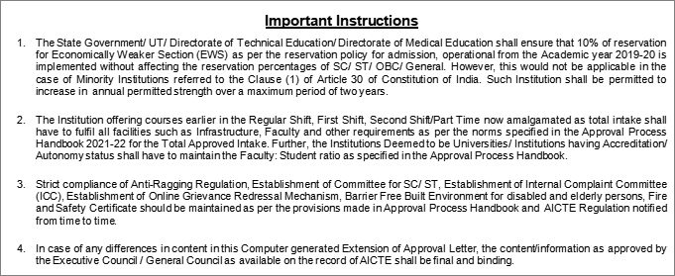

|  |  |  |
| --- | --- | --- |
|  | | **Prof.Rajive Kumar Member Secretary, AICTE** |
| **Copy ** to:** |  |  |
| **1.** | **The Director of Technical Education**, Andhra Pradesh** |  |
| **2.** | **The Registrar**,** |  |
|  | **Jawaharlal Nehru Technological University, Kakinada** |  |
| **3.** | **The Principal / Director,**  **NRI INSTITUTE OF TECHNOLOGY** |  |
|  | **Visadala (Po)** |  |
|  | **Medikonduru(Md)** |  |
|  | **Guntur-522438** |  |
|  | **Andhra Pradesh,** |  |
|  | **Guntur,Guntur,** |  |
|  | **Andhra Pradesh,522438** |  |
| **4.** | **The Secretary / Chairman,**  **C/O NRI INSTITUTE OF TECHNOLOGY,VISADALA (PO),MEDIKONDURU (MD)** |  |
|  | **GUNTUR,GUNTUR** |  |
|  | **Andhra Pradesh,522438** |  |
| **5.** | **The Regional Officer,**  **All India Council for Technical Education** |  |
|  | **First Floor, old BICARD Building** |  |
|  | **Jawaharlal Nehru Technological University** |  |
|  | **Masab Tank, Hyderabad-500076** |  |
| **6.** | **Guard File(AICTE)** |  |

**Note: Validity of the Course details may be verified at** <http://www.aicte-india.org/> **.**

|  |
| --- |
|  |
|  |  |

**\*\* Individual Approval letter copy will not be communicated through Post/Email. However, consolidated list of Approved Institutions(bulk) will be shared through official Email Address to the concerned Authorities mentioned above.**

**2019-20 AICTE APPROVAL LETTER**

**All India Council for Technical Education**

**(A Statutory body under Ministry of HRD, Govt. of India)**

**Nelson Mandela Marg,Vasant Kunj, New Delhi-110070 Website:** [www.aicte-india.org](http://www.aicte-india.org/)

**APPROVAL PROCESS 2019-20**

**Extension of Approval (EoA)**

**F.No. South-Central/1-4261368458/2019/EOA Date: 10-Apr-2019**

**To,**

**The Principal Secretary**

**(Higher Education) Govt. of Andhra Pradesh, J Block, 4th Floor, Secretariat Building, Hyderabad-500022**

**Sub: Extension of Approval for the Academic Year 2019-20**

**Ref: Application of the Institution for Extension of approval for the Academic Year 2019-20 Sir/Madam,**

**In terms of the provisions under the All India Council for Technical Education (Grant of Approvals for Technical Institutions) Regulations 2018 notified by the Council vide notification number F.No.AB/AICTE/REG/2018 dated 31/12/2018 and norms standards, procedures and conditions prescribed by the Council from time to time, I am directed to convey the approval to**

|  |  |  |  |
| --- | --- | --- | --- |
| **Permanent Id** | **1-6140036** | **Application Id** | **1-4261368458** |
| **Name of the Institute** | **NRI INSTITUTE OF TECHNOLOGY** | **Name of the Society/Trust** | **MNK EDUCATIONAL SOCIETY** |
| **Institute Address** | **VISADALA (PO) MEDIKONDURU(MD) GUNTUR-522438**  **ANDHRA PRADESH, GUNTUR,**  **GUNTUR, Andhra Pradesh, 522438** | **Society/Trust Address** | **C/O NRI INSTITUTE OF TECHNOLOGY,VISADALA (PO),MEDIKONDURU (MD),GUNTUR,GUNTUR,Andhra**  **Pradesh,522438** |
| **Institute Type** | **Unaided - Private** | **Region** | **South-Central** |

|  |  |  |  |
| --- | --- | --- | --- |
| **Opted for Change from Women to Co-Ed and vice versa** | **No** | **Change from Women to Co-Ed and vice versa Approved or Not** | **NA** |
| **Opted for Change of Name** | **No** | **Change of Name Approved or Not** | **NA** |
| **Opted for Change of Site/Location** | **No** | **Change of Site/Location Approved or Not** | **NA** |
| **Opted for Conversion from Degree to Diploma or vice versa** | **No** | **Conversion for Degree to Diploma or vice versa Approved or Not** | **NA** |
| **Opted for Organization Name Change** | **No** | **Change of Organization Name Approved or Not** | **NA** |
| **Opted for Merger of Institution** | **No** | **Merger of Institution Approved or Not** | **NA** |
| **Opted for Introduction of New Program/Level** | **No** | **Introduction of Program/Level Approved or Not** | **NA** |

**To conduct following Courses with the Intake indicated below for the Academic Year 2019-20**

|  |  |  |  |  |  |  |  |  |
| --- | --- | --- | --- | --- | --- | --- | --- | --- |
| **Program** | **Shift** | **Level** | **Course** | **FT/PT+** | **Affiliating Body (Univ/Body)** | **Intake Approved for 2019-20** | **NRI Approval Status** | **PIO / FN / Gulf quota/ OCI/ Approval Status** |
| **Engineering And Technology** | **1st** | **Post Graduate** | **Structural Engineering** | **FT** | **Jawaharlal Nehru Technological University, Kakinada** | **18** | **NA** | **NA** |
| **Engineering And Technology** | **1st** | **Under Graduate** | **Mechanical Engineering** | **FT** | **Jawaharlal Nehru Technological University, Kakinada** | **120** | **NA** | **NA** |
| **Engineering And** | **1st** | **Under** | **Computer Sceince** | **FT** | **Jawaharlal Nehru** | **120** | **NA** | **NA** |

|  |  |  |  |  |  |  |  |  |
| --- | --- | --- | --- | --- | --- | --- | --- | --- |
| **Technology** |  | **Graduate** | **& Engineering** |  | **Technological University, Kakinada** |  |  |  |
| **Engineering And Technology** | **1st** | **Under Graduate** | **Electronics & Communication Engg** | **FT** | **Jawaharlal Nehru Technological University, Kakinada** | **180** | **NA** | **NA** |
| **Engineering And Technology** | **1st** | **Under Graduate** | **Civil Engineering** | **FT** | **Jawaharlal Nehru Technological University, Kakinada** | **120** | **NA** | **NA** |
| **Engineering And Technology** | **1st** | **Under Graduate** | **Electrical And Electronics Engineering** | **FT** | **Jawaharlal Nehru Technological University, Kakinada** | **60** | **NA** | **NA** |
| **Management** | **1st** | **Post Graduate** | **Masters In Business Administration** | **FT** | **Jawaharlal Nehru Technological University, Kakinada** | **120** | **NA** | **NA** |
| **Engineering And Technology** | **1st** | **Post Graduate** | **Computer Science And Engineering** | **FT** | **Jawaharlal Nehru Technological University, Kakinada** | **36** | **NA** | **NA** |
| **Engineering And Technology** | **1st** | **Post Graduate** | **Digital Electronics And Communication Systems** | **FT** | **Jawaharlal Nehru Technological University, Kakinada** | **18** | **NA** | **NA** |

**+FT –Full Time,PT-Part Time**

**In case of any differences in content in this Computer generated Extension of Approval Letter, the content/information as approved by the Executive Council / General Council as available on the record of AICTE shall be final and binding.**

**Strict compliance of Anti-Ragging Regulation: - Approval is subject to strict compliance of provisions made in AICTE Regulation notified vide F. No. 37- 3/Legal/AICTE/2009 dated July 1, 2009 for Prevention and Prohibition of Ragging in Technical Institutions. In case Institution fails to take adequate steps to Prevent Ragging or fails to act in accordance with AICTE Regulation or fails to punish perpetrators or incidents of Ragging, it will be liable to take any action as defined under clause 9(4) of the said Regulation.**

**It is mandatory to comply all the essential requirements as given in APH 2019-20(appendix 6)**

|  |
| --- |
|  |
|  |  |

**Prof. A.P Mittal Member Secretary, AICTE**

**Copy to:**

1. **The Director Of Technical Education**, Andhra Pradesh**

1. **The Registrar**,**

**Jawaharlal Nehru Technological University, Kakinada**

1. **The Principal / Director, Nri Institute Of Technology Visadala (Po) Medikonduru(Md)**

**Guntur-522438 Andhra Pradesh, Guntur,Guntur,**

**Andhra Pradesh,522438**

1. **The Secretary / Chairman,**

**Mnk Educational Society**

**C/O Nri Institute Of Technology,Visadala (Po),Medikonduru (Md). Guntur,Guntur,**

**Andhra Pradesh,522438**

1. **The Regional Officer,**

**All India Council for Technical Education First Floor, old BICARD Building Jawaharlal Nehru Technological University Masab Tank, Hyderabad-500076**

1. **Guard File(AICTE)**

**Note: Validity of the Course details may be verified at** <http://www.aicte-india.org/>

**2018-19 AICTE APPROVAL LETTER**

**All India Council for Technical Education**

**(A Statutory body under Ministry of HRD, Govt. of India)**

**Nelson Mandela Marg,Vasant Kunj, New Delhi-110070 Website:** [www.aicte-india.org](http://www.aicte-india.org/)

**APPROVAL PROCESS 2018-19**

**Extension of Approval (EoA)**

**F.No. South-Central/1-3513860325/2018/EOA Date: 04-Apr-2018**

**To,**

**The Principal Secretary**

**(Higher Education) Govt. of Andhra Pradesh, J Block, 4th Floor, Secretariat Building, Hyderabad-500022**

**Sub: Extension of Approval for the Academic Year 2018-19**

**Ref: Application of the Institution for Extension of approval for the Academic Year 2018-19 Sir/Madam,**

**In terms of the provisions under the All India Council for Technical Education (Grant of Approvals for Technical Institutions) Regulations 2016 notified by the Council vide notification number F.No.AB/AICTE/REG/2016 dated 30/11/2016 and amended on December 5, 2017 and norms standards, procedures and conditions prescribed by the Council from time to time, I am directed to convey the approval to**

|  |  |  |  |
| --- | --- | --- | --- |
| **Permanent Id** | **1-6140036** | **Application Id** | **1-3513860325** |
| **Name of the Institute** | **NRI INSTITUTE OF TECHNOLOGY** | **Name of the Society/Trust** | **MNK EDUCATIONAL SOCIETY** |
| **Institute Address** | **VISADALA (PO) MEDIKONDURU(MD) GUNTUR-522438**  **ANDHRA PRADESH, GUNTUR,**  **GUNTUR, Andhra Pradesh, 522438** | **Society/Trust Address** | **C/O NRI INSTITUTE OF TECHNOLOGY,VISADALA (PO),MEDIKONDURU (MD),GUNTUR,GUNTUR,Andhra**  **Pradesh,522438** |
| **Institute Type** | **Unaided - Private** | **Region** | **South-Central** |

|  |  |  |  |
| --- | --- | --- | --- |
| **Opted for Change from Women to Co-Ed and vice versa** | **No** | **Change from Women to Co-Ed and vice versa Approved or Not** | **NA** |
| **Opted for Change of Name** | **No** | **Change of Name Approved or Not** | **NA** |
| **Opted for Change of Site** | **No** | **Change of Site Approved or Not** | **NA** |
| **Opted for Conversion from Degree to Diploma or vice versa** | **No** | **Conversion for Degree to Diploma or vice versa Approved or Not** | **NA** |
| **Opted for Organization Name Change** | **No** | **Change of Organization Name Approved or Not** | **NA** |

**To conduct following Courses with the Intake indicated below for the Academic Year 2018-19**

|  |  |  |  |  |  |  |  |  |  |
| --- | --- | --- | --- | --- | --- | --- | --- | --- | --- |
| **Program** | **Shift** | **Level** | **Course** | **FT/PT+** | **Affiliating Body (Univ/Body)** | **Intake Approved for 2018-19** | **NRI Approval Status** | **PIO / FN / Gulf quota/ OCI/ Approval Status** | **Foreign Collaboration**  **/Twining Program Approval Status\*** |
| **ENGINEERING AND TECHNOLOGY** | **1st** | **POST GRADUATE** | **STRUCTURAL ENGINEERING** | **FT** | **Jawaharlal Nehru Technological University, Kakinada** | **18** | **NA** | **NA** | **NA** |
| **ENGINEERING AND TECHNOLOGY** | **1st** | **UNDER GRADUATE** | **MECHANICAL ENGINEERING** | **FT** | **Jawaharlal Nehru Technological University, Kakinada** | **120** | **NA** | **NA** | **NA** |
| **ENGINEERING AND TECHNOLOGY** | **1st** | **UNDER GRADUATE** | **COMPUTER SCEINCE & ENGINEERING** | **FT** | **Jawaharlal Nehru Technological University, Kakinada** | **120** | **NA** | **NA** | **NA** |
| **ENGINEERING** | **1st** | **UNDER** | **ELECTRONICS &** | **FT** | **Jawaharlal Nehru** | **180** | **NA** | **NA** | **NA** |

|  |  |  |  |  |  |  |  |  |  |
| --- | --- | --- | --- | --- | --- | --- | --- | --- | --- |
| **AND TECHNOLOGY** |  | **GRADUATE** | **COMMUNICATION ENGG** |  | **Technological University, Kakinada** |  |  |  |  |
| **ENGINEERING AND TECHNOLOGY** | **1st** | **UNDER GRADUATE** | **CIVIL ENGINEERING** | **FT** | **Jawaharlal Nehru Technological University, Kakinada** | **120** | **NA** | **NA** | **NA** |
| **ENGINEERING AND TECHNOLOGY** | **1st** | **UNDER GRADUATE** | **ELECTRICAL AND ELECTRONICS ENGINEERING** | **FT** | **Jawaharlal Nehru Technological University, Kakinada** | **60** | **NA** | **NA** | **NA** |
| **MANAGEMEN T** | **1st** | **POST GRADUATE** | **MASTERS IN BUSINESS ADMINISTRATION** | **FT** | **Jawaharlal Nehru Technological University, Kakinada** | **120** | **NA** | **NA** | **NA** |
| **ENGINEERING AND TECHNOLOGY** | **1st** | **POST GRADUATE** | **COMPUTER SCIENCE AND ENGINEERING** | **FT** | **Jawaharlal Nehru Technological University, Kakinada** | **36** | **NA** | **NA** | **NA** |
| **ENGINEERING AND TECHNOLOGY** | **1st** | **POST GRADUATE** | **DIGITAL ELECTRONICS AND COMMUNICATION SYSTEMS** | **FT** | **Jawaharlal Nehru Technological University, Kakinada** | **18** | **NA** | **NA** | **NA** |

**+FT –Full Time,PT-Part Time**

**In case of any differences in content in this Computer generated Extension of Approval Letter, the content/information as approved by the Executive Council / General Council as available on the record of AICTE shall be final and binding.**

**Strict compliance of Anti-Ragging Regulation: - Approval is subject to strict compliance of provisions made in AICTE Regulation notified vide F. No. 37-3/Legal/AICTE/2009 dated July 1, 2009 for Prevention and Prohibition of Ragging in Technical Institutions. In case Institution fails to take adequate steps to Prevent Ragging or fails to act in accordance with AICTE Regulation or fails to punish perpetrators or incidents of Ragging, it will be liable to take any action as defined under clause 9(4) of the said Regulation.**

**Prof. A.P Mittal Member Secretary, AICTE**

**Copy to:**

1. **The Regional Officer,**

**All India Council for Technical Education First Floor, old BICARD Building Jawaharlal Nehru Technological University Masab Tank, Hyderabad-500076**

1. **The Director Of Technical Education**, Andhra Pradesh**
2. **The Registrar**,**

**Jawaharlal Nehru Technological University, Kakinada**

1. **The Principal / Director,**

**NRI INSTITUTE OF TECHNOLOGY VISADALA (PO) MEDIKONDURU(MD)**

**GUNTUR-522438 ANDHRA PRADESH, GUNTUR,GUNTUR,**

**Andhra Pradesh,522438**

1. **The Secretary / Chairman,**

**MNK EDUCATIONAL SOCIETY**

**C/O NRI INSTITUTE OF TECHNOLOGY,VISADALA (PO),MEDIKONDURU (MD), GUNTUR,GUNTUR,**

**Andhra Pradesh,522438**

1. **Guard File(AICTE)**

**Note: Validity of the Course details may be verified at** <http://www.aicte-india.org/>

**2017-18 AICTE APPROVAL LETTER**

 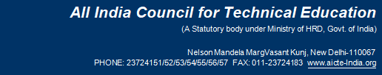

**F.No. South-Central/1-3326027771/2017/EOA Date: 30-Mar-2017 To,**

**The Principal Secretary**

**(Higher Education) Govt. of Andhra Pradesh, J Block, 4th Floor, Secretariat Building, Hyderabad-500022**

**Sub: Extension of approval for the academic year 2017-18**

**Ref: Application of the Institution for Extension of approval for the academic year 2017-18 Sir/Madam,**

**In terms of the provisions under the All India Council for Technical Education (Grant of Approvals for Technical Institutions) Regulations 2016 notified by the Council vide notification number F.No.AB/AICTE/REG/2016 dated 30/11/2016 and norms standards, procedures and conditions prescribed by the Council from time to time, I am directed to convey the approval to**

|  |  |  |  |
| --- | --- | --- | --- |
| **Permanent Id** | **1-6140036** | **Application Id** | **1-3326027771** |
| **Name of the Institute** | **NRI INSTITUTE OF TECHNOLOGY** | **Institute Address** | **VISADALA (PO) MEDIKONDURU(MD) GUNTUR-522438**  **ANDHRA PRADESH, GUNTUR, GUNTUR, Andhra**  **Pradesh, 522438** |
| **Name of the Society/Trust** | **MNK EDUCATIONAL SOCIETY** | **Society/Trust Address** | **C/O NRI INSTITUTE OF TECHNOLOGY,VISADALA (PO),MEDIKONDURU (MD),GUNTUR,GUNTUR,Andhra Pradesh,522438** |
| **Institute Type** | **Unaided - Private** | **Region** | **South-Central** |

|  |  |  |  |  |  |
| --- | --- | --- | --- | --- | --- |
| **Opted for change from Women to Co-ed and Vice versa** | **No** | **Opted for change of name** | **No** | **Opted for change of site** | **No** |
| **Change from Women to Co-ed approved and Vice versa** | **Not Applicable** | **Change of name Approved** | **Not Applicable** | **Change of site Approved** | **Not Applicable** |
| **Opted for Conversion from degree to diploma** | **No** | **Opted for Conversion from diploma to degree** | **No** | **Conversion (degree to diploma or vice-a- versa) Approved** | **Not Applicable** |

**To conduct following courses with the intake indicated below for the academic year 2017-18**

|  |  |  |  |  |  |  |  |  |  |  |
| --- | --- | --- | --- | --- | --- | --- | --- | --- | --- | --- |
| **Application Id: 1-3326027771** | | | **Course** | **Full/Part Time** | **Affiliating Body** | **Intake Approved for 2016-17** | **Intake Approved for 2017-18** | **NRI Approval status** | **PIO / FN / Gulf quota/ OCI/**  **Approval status** | **Foreign Collaborarion/Twining Program Approval status\*** |
| **Program** | **Shift** | **Level** |
| **ENGINEERIN G AND** | **1st Shift** | **POS T GRA** | **COMPUTER SCIENCE AND ENGINEERING** | **FULL TIME** | **Jawaharlal Nehru Technological** | **36** | **36** | **NA** | **NA** | **NA** |

**Application Number: 1-3326027771 Page 1 of 3**

**Note: This is a Computer generated Report.No signature is required. Letter Printed On:17 April 2017 Printed By : AE1739071**

 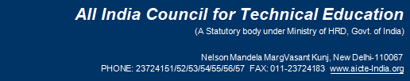

|  |  |  |  |  |  |  |  |  |  |  |
| --- | --- | --- | --- | --- | --- | --- | --- | --- | --- | --- |
| **TECHNOLO GY** |  | **DUA TE** |  |  | **University, Kakinada** |  |  |  |  |  |
| **ENGINEERIN G AND TECHNOLO GY** | **1st Shift** | **POS T GRA DUA TE** | **DIGITAL ELECTRONICS AND COMMUNICATI ON SYSTEMS** | **FULL TIME** | **Jawaharlal Nehru Technological University, Kakinada** | **18** | **18** | **NA** | **NA** | **NA** |
| **ENGINEERIN G AND TECHNOLO GY** | **1st Shift** | **POS T GRA DUA TE** | **STRUCTURAL ENGINEERING** | **FULL TIME** | **Jawaharlal Nehru Technological University, Kakinada** | **18** | **18** | **NA** | **NA** | **NA** |
| **ENGINEERIN G AND TECHNOLO GY** | **1st Shift** | **UND ER GRA DUA TE** | **CIVIL ENGINEERING** | **FULL TIME** | **Jawaharlal Nehru Technological University, Kakinada** | **120** | **120** | **NA** | **NA** | **NA** |
| **ENGINEERIN G AND TECHNOLO GY** | **1st Shift** | **UND ER GRA DUA TE** | **COMPUTER SCEINCE & ENGINEERING** | **FULL TIME** | **Jawaharlal Nehru Technological University, Kakinada** | **120** | **120** | **NA** | **NA** | **NA** |
| **ENGINEERIN G AND TECHNOLO GY** | **1st Shift** | **UND ER GRA DUA TE** | **ELECTRICAL AND ELECTRONICS ENGINEERING** | **FULL TIME** | **Jawaharlal Nehru Technological University, Kakinada** | **60** | **60** | **NA** | **NA** | **NA** |
| **ENGINEERIN G AND TECHNOLO GY** | **1st Shift** | **UND ER GRA DUA TE** | **ELECTRONICS**  **& COMMUNICATI ON ENGG** | **FULL TIME** | **Jawaharlal Nehru Technological University, Kakinada** | **180** | **180** | **NA** | **NA** | **NA** |
| **ENGINEERIN G AND TECHNOLO GY** | **1st Shift** | **UND ER GRA DUA TE** | **MECHANICAL ENGINEERING** | **FULL TIME** | **Jawaharlal Nehru Technological University, Kakinada** | **120** | **120** | **NA** | **NA** | **NA** |
| **MANAGEME NT** | **1st Shift** | **POS T GRA DUA TE** | **MASTERS IN BUSINESS ADMINISTRATI ON** | **FULL TIME** | **Jawaharlal Nehru Technological University, Kakinada** | **120** | **120** | **NA** | **NA** | **NA** |

**The above mentioned approval is subject to the condition that**

**NRI INSTITUTE OF TECHNOLOGY**

**shall follow and adhere to the Regulations, guidelines and directions issued by AICTE from time to time and the undertaking / affidavit given by the institution along with the application submitted by the institution on portal.**

**Application Number: 1-3326027771 Page 2 of 3**

**Note: This is a Computer generated Report.No signature is required. Letter Printed On:17 April 2017 Printed By : AE1739071**

** **

**In case of any differences in content in this Computer generated Extension of Approval Letter, the content/information as approved by the Executive Council / General Council as available on the record of AICTE shall be final and binding.**

**Strict compliance of Anti-Ragging Regulation:- Approval is subject to strict compliance of provisions made in AICTE Regulation notified vide F. No. 37-3/Legal/AICTE/2009 dated July 1, 2009 for Prevention and Prohibition of Ragging in Technical Institutions. In case Institution fails to take adequate steps to Prevent Ragging or fails to act in accordance with AICTE Regulation or fails to punish perpetrators or incidents of Ragging, it will be liable to take any action as defined under clause 9(4) of the said Regulation.**

**Note: Validity of the course details may be verified at** [www.aicte-india.org](http://www.aicte-india.org/)

**Copy to:**

1. **The Regional Officer,**

**All India Council for Technical Education First Floor, old BICARD Building Jawaharlal Nehru Technological University Masab Tank, Hyderabad-500076**

1. **The Director Of Technical Education**,**

**Andhra Pradesh**

1. **The Registrar**,**

**Jawaharlal Nehru Technological University, Kakinada**

1. **The Principal / Director,**

**NRI INSTITUTE OF TECHNOLOGY VISADALA (PO) MEDIKONDURU(MD)**

**GUNTUR-522438 ANDHRA PRADESH, GUNTUR,GUNTUR,**

**Andhra Pradesh,522438**

1. **The Secretary / Chairman,**

**MNK EDUCATIONAL SOCIETY**

**C/O NRI INSTITUTE OF TECHNOLOGY,VISADALA (PO),MEDIKONDURU (MD), GUNTUR,GUNTUR,**

**Andhra Pradesh,522438**

**Prof. A.P Mittal Member Secretary, AICTE**

1. **Guard File(AICTE)**

**Note: ** - Approval letter copy will not be communicated through post/email. However, provision is made in the portal for downloading Approval letter through Authorized login credentials allotted to concerned DTE/Registrar.**

***---- Information for***

**Mandatory Disclosures**

**Mandatory Disclosures**

1. **Name of the Institution**

**NRI Institute of Technology**

**Visadala post, Medikonduru mandal, Guntur – 522438. A.P. India E-Mail:** [nriit.guntur@gmail.com](mailto:nriit.guntur@gmail.com)

**Phone: 0863-2344300**

1. **Name and address of the Trust**

**M.N.K. Educational Society**

**Visadala post, Medikonduru mandal, Guntur – 522438. A.P. India E-Mail:** [nriit.guntur@gmail.com](mailto:nriit.guntur@gmail.com)

**Phone: 0863-2344300**

1. **Name and Address of the Principal**

**Dr.Kota Srinivasu**

**E-Mail:** [kota.srinivasu@gmail.com](mailto:kota.srinivasu@gmail.com) **Mobile: 9492940860**

1. **Name of the affiliating University**

**Jawaharlal Nehru Technological University, Kakinada Kakinada, Andhra Pradesh 533003**

1. **Governance Members:**

**President**

**Our President Dr. Apparao Mukkamala is a radiologist currently based in Flint, MI. In 2007, he became the president of the Michigan State Medical Society (MSMS). Before that, he served as president of the Genesee County Medical Society and as a treasurer of MSMS.**

**Dr. Mukkamala was also the chair of the Department of Radiology at Hurley Medical Center and a member of the hospital’s board of directors.**

**In addition, he serves as a clinical professor of radiology at the Michigan State University College of Human Medicine. He is the primary founder of the NRI Medical Center and Medical School in Andhra Pradesh, India, which accepts 150 students in its acclaimed medical program yearly. The institution delivers relatively low-cost**

**medical care to 100,000 inpatients and 1.2 million outpatients. He and his wife, Dr. Sumathi R. Mukkamala, are the founders of Chinmaya Vijaya Orphanage, which delivers care and education to orphaned and abandoned girls throughout India.**

**Secretary & Correspondent**

**Philanthropist, Educationist,Visionary.…are some of the attributes which have been associated with Secretary&Correspondent Sri Alapati Rajendra Prasad. the Ex-Technical Education Minister of Andhra Pradesh is the secretary and correspondent of NRI Institute of Technology He is a visionary during whose tenure as minister, technical education in Andhra Pradesh was given a major face lift.He is the driving force behind NRI Institute of Technology. NRI Academy, NRI Indian Springs School and NRI Agritech.**

**Academic Advisory Body**

|  |  |  |  |
| --- | --- | --- | --- |
| **S.NO** | **NAME** | **Designation** | **Position** |
| **1** | **Dr. Mukkamala Apparao** | **Doctor, USA, President MNK Educational Society** | **Chairman** |
| **2** | **Sri Alapati Rajendra Prasad** | **MLA, Tenali Assembly Constitution, Secretary & Correspondent MNK Educational Society** | **Member** |
| **3** | **Sri. Nallabothu Srinivasa Rao** | **Business** | **Member** |
| **4** | **Sri. Manam Srinivasa Rao** | **Treasurer, MNK Educational Society** | **Member** |
| **5** | **Smt.Alapati Madhavi** | **Business** | **Member** |
| **6** | **Smt.M.Sumathi** | **Business** | **Member** |
| **7** | **Sri V.Vara Prasad** | **University College of Engineering, Kakinada, University Nominee** | **Member** |
| **8** | **AICTE Nominee** | **Communicated** | **Member** |

|  |  |  |  |
| --- | --- | --- | --- |
| **9** | **Sri.J.Murali Mohan** | **Educationist** | **Member** |
| **10** | **Sri.Ch Ramesh** | **Industrialist** | **Member** |
| **11** | **Dr. Kota Srinivasu** | **Professor& Principal** | **Member** |
| **12** | **Dr. Zia Ur Rehman** | **HOD, MBA** | **Member** |

***ANTI RAGGING COMMITTEE***

|  |  |  |  |
| --- | --- | --- | --- |
| **S.NO** | **Name** | **Designation &**  **Department** | **Position** |
| **1** | **Dr.K.Srinivasu, Principal** | **Chairman** | **9492940860** |
| **2** | **Dr.Zia Ur Rehman, HoD, MBA** | **Convener** | **9703301199** |
| **3** | **Sub-Inspector Medikonduru P.S** | **Sub-Inspector** | **9491067815** |
| **4** | **Dr.K.Srihari Rao, Vice-Principal** | **Member** | **9246400540** |
| **5** | **Dr.K.Chandra Mouli, HoD, C.E** | **Member** | **9347052319** |
| **6** | **Mr.D.Koteswara Rao, HoD-DS**  **& IT** | **Member** | **8885552793** |
| **7** | **Mr.J.Krishna Kishore, Exam cell**  **in-charge** | **Member** | **94090728858** |
| **8** | **Mr.V.K.Prathap, Asst. Prof., CSE** | **Member** | **9985678943** |
| **9** | **Mrs.P.Anupama, Asst. Prof.,**  **MBA** | **Member** | **7780334588** |
| **10** | **Mr.M.Chaitanya Nava Kumar, Asst. Prof., CE** | **Member** | **8121760067** |
|  | **Mr.I.Nageswara Rao, Asst. Prof., CSE(DS)** | **Member** | **9963918936** |

***INTERNAL COMPLAINT COMMITTEE***

|  |  |  |  |  |
| --- | --- | --- | --- | --- |
| **S.NO** | **Name** | **Department** | **Designation** | **Position** |
| **1** | **Dr.K.Srinivasu** | **CIVIL** | **Principal** | **Chairman** |
| **2** | **Mrs.K.Sujata** | **ECE** | **Assoc.Professor** | **Coordinator** |

|  |  |  |  |  |
| --- | --- | --- | --- | --- |
| **3** | **Smt.P.Sujatha** | **S&H** | **Assoc .Prof** | **Member** |
| **4** | **Smt.P.Anupama** | **MBA** | **Asst. Prof** | **Member** |
| **5** | **Smt.B.Sowjanya** | **CSE** | **Asst. Prof** | **Member** |
| **6** | **Ms.A.MedhaSrirunalini** | **CE** | **Asst. Prof** | **Member** |
| **7** | **MsT.NagaBhargavi** | **EEE** | **Asst. Prof** | **Member** |

***COMMITTEE FOR SC / ST***

|  |  |  |  |
| --- | --- | --- | --- |
| **S.NO** | **Name** | **Designation** | **Position** |
| **1** | **Mr.P.Ravi Kumar** | **HOD.Mech** | **Convener/ Liaison Officer** |
| **2** | **Dr.V.NagaMalleswari** | **HOD, EEE** | **Member** |
| **3** | **Mrs.M.M.Junitha** | **Assoc.prof, ECE** | **Member** |
| **4** | **Mr.G.Mahesh** | **Assist.Prof.S&H** | **Member** |
| **5** | **Mr.P.MANOHAR** | **Assist.Prof.ECE** | **Member** |

***IQAC COMMITTEE***

|  |  |  |  |
| --- | --- | --- | --- |
| **S.NO** | **Name** | **Designation** | **Position** |
| **1** | **Dr. K Srinivasu** | **Principal** | **Chairperson** |
| **2** | **Dr. J Chandra sekhar** | **Prof. CSE** | **Coordinator** |
| **3** | **Mr. A Rajendra Prasad** | **Secretary** | **Management** |
| **4** | **Dr. Srihari** | **Vice Principal, Dept. of ECE** | **Administrative Officers** |
| **5** | **Dr Zia urRehman** | **HoD - Dept. of MBA** | **Administrative**  **Officers** |
| **6** | **Dr. K Chandra mouli** | **HoD - Dept. of CE** | **Administrative**  **Officers** |
| **7** | **Prof. J. Ramu** | **HoD - Dept. of CSE** | **Administrative Officers** |
| **8** | **Mr.Koteswar Rao** | **HoD – Dept. of IT & CDS** | **Administrative**  **Officers** |
| **9** | **Prof P Ravi Kumar** | **HoD - Dept. of ME** | **Administrative**  **Officers** |

|  |  |  |  |
| --- | --- | --- | --- |
| **10** | **Dr.Malleswari** | **HoD - Dept. of EEE** | **Administrative**  **Officers** |
| **11** | **Mr B Seetharamaiah** | **Admin Manager** | **Administrative**  **Officers** |
| **12** | **Mr. K Srinivas Rao** | **HoD - Dept. of S&H** | **Administrative**  **Officers** |
| **13** | **Mr Chaitanya** | **Exam Section Incharge** | **Administrative**  **Officers** |
| **14** | **Dr B Saiadaiah** | **Professor, Dept of ECE** | **Faculty Members** |
| **15** | **Mrs.Anupama** | **Asst. Prof., Dept. of**  **MBA** | **Faculty Members** |
| **16** | **Ms U Gayathri** | **Asst. Prof., Dept. of ME** | **Faculty Members** |
| **17** | **Mr.I.Nageswara Rao** | **Asst. Prof., Dept. of IT** | **Faculty Members** |
| **18** | **Mr. J S Naga chatanya** | **Asst. Prof., Dept. of CE** | **Faculty Members** |
| **19** | **Mr Raja sekhar** | **Asst Prof, TPO** | **Faculty Members** |
| **20** | **Mr. Pamulapalli Srinivas Rao** | **Ex Sarpanch,**  **Pericheralla** | **Local Society** |
| **21** | **Mr. M Shanmukanagagopi** | **Dept. of ME,**  **19KP1A0308** | **Students** |
| **22** | **Ms. Noor**  **bashayasmidhasheehaan** | **Dept.of CSE,**  **20KP1A0572** | **Students** |
| **23** | **Mr. Chatanya** | **CE** | **Alumni** |
| **24** | **Mrs. Sk Anju** | **ECE** | **Alumni** |
| **25** | **Sri. K Subramanyam** | **Proprietor, Kumar**  **Pumps, Guntur** | **Industrialist** |
| **26** | **Mr. Pamulapalli Srinivas Rao** | **Ex Sarpanch,**  **Pericheralla** | **Local Society** |
| **27** | **Mr. M Shanmukanagagopi** | **Dept. of ME, 19KP1A0308** | **Students** |

1. **Programmes**

**Courses offered and Intake**

***Under Graduate ( UG):***

***Course Intake***

**Computer Science and Engineering (CSE) 150**

**Computer Science and Engineering – Data Science (CSD) 180**

**Artificial Intelligence and Machine Learning (AI & ML) 60**

**Information Technology (IT) 60**

**Electronics and Communication Engineering (ECE) 120**

**VLSI 60**

**Civil Engineering (CE) 30**

*Post Graduate ( PG):*

MBA 60

**MCA 120**

**M.Tech (CSE) 18**

**M.Tech (DECS) 18**

**M.Tech (SE) 18**

***Placements: 2019-20***

|  |  |  |  |  |
| --- | --- | --- | --- | --- |
| S.N O | REG.NO | Branc h | Company Name | Package |
| 1 | S.DILEEP | CE | ILM | 2.10 LPA |
| 2 | SK.NAJEER | CE | ILM | 2.10 LPA |
| 3 | T.SAI PRIYA MEGHANA | CSE | ABC | 1.2 LPA |
| 4 | K.SRILAKSHMI | CSE | ABC | 1.2 LPA |
| 5 | Y.KARTHIK | CSE | ABC | 1.2 LPA |
| 6 | MOHAN VAMSI RAMANAPUDI | CSE | TCS | 4.08 LPA |
| 7 | SHAIK UMME RUMAAN | CSE | TCS | 4.08 LPA |
| 8 | SAI PRIYA MEGHANA  TATAVARTHI | CSE | TCS | 4.08 LPA |
| 9 | NAGA SAI PUJITHA KURAPATI | CSE | TCS | 4.08 LPA |
| 10 | LATHA CHUNDURI | CSE | TCS | 4.08 LPA |
| 11 | MS.YALAMANDALA SUHANI | CSE | ILM | 2.10 LPA |
| 12 | NAGABHAIRU RAMYA | CSE | ILM | 2.10 LPA |
| 13 | NIMMAGADDA SAHITHI PRIYA | CSE | ILM | 2.10 LPA |
| 14 | VENIGALLA SRI SAI BHAVANA | CSE | ILM | 2.10 LPA |
| 15 | TATAVARTHI SAI PRIYA MEGHANA | CSE | ILM | 2.10 LPA |
| 16 | SHAIK SHAHIDA BEGAM | CSE | ILM | 2.10 LPA |
| 17 | PENUMUCHU NARASIMHA MANASA | CSE | ILM | 2.10 LPA |
| 18 | PAREPALLI DURGA PRAVALLIKA | CSE | ILM | 2.10 LPA |
| 19 | LAKSHMISETTY HEMEEMA | CSE | ILM | 2.10 LPA |
| 20 | BITTU LAKSHMI DURGA PRASANNA | CSE | ILM | 2.10 LPA |
| 21 | KAUSALYA GUDE | CSE | ILM | 2.10 LPA |
| 22 | GANNAMANENI LAKSHMITRIVENI | CSE | ILM | 2.10 LPA |

|  |  |  |  |  |
| --- | --- | --- | --- | --- |
| 23 | GOLI NAGA VIVEK | CSE | ILM | 2.10 LPA |
| 24 | CHIMATA MANOHAR | CSE | ILM | 2.10 LPA |
| 25 | KURAPATI VENKATA NAGA SAI  YASWANTH | CSE | ILM | 2.10 LPA |
| 26 | KOTA VENKATA KHAJA DEVI | CSE | ILM | 2.10 LPA |
| 27 | MEENAKSHI VUTLA | CSE | ILM | 2.10 LPA |
| 28 | KARTHIK YENUGANTI | CSE | CHOLA MS GENERAL  INSURANCE PVT LTD | 3.0 LPA |
| 29 | TADEPALLI U N V S A BHANUPRAKASH | CSE | CHOLA MS GENERAL INSURANCE PVT  LTD | 3.0 LPA |
| 30 | RAMANAPUDI MOHAN VAMSI | CSE | CHOLA MS GENERAL INSURANCE PVT  LTD | 3.0 LPA |
| 31 | BODEPUDI PUJITHA | CSE | IBM | 2.80 LPA |
| 32 | ADAPA LASYA PRIYA VENKATAPRASUNA | CSE | IBM | 2.80 LPA |
| 33 | IPPALA DEEPTHIREDDY | CSE | IBM | 2.80 LPA |
| 34 | SAHITHI PRIYA NIMMAGADDA | CSE | IBM | 2.80 LPA |
| 35 | BEHERA VENKAT | CSE | CTS | 4.55 LPA |
| 36 | SAHITHIPRIYA NIMMAGADDA | CSE | CTS | 4.55 LPA |
| 37 | KAUSALYA GUDE | CSE | TECHMAHINDRA | 1.36 LPA |
| 38 | PERAM DIVYA | CSE | TECHMAHINDRA | 1.36 LPA |
| 39 | KAUSALYA GUDE | CSE | TECHMAHINDRA | 1.36 LPA |
| 40 | KAVURI VENKATESH | CSE | TECHMAHINDRA | 1.36 LPA |
| 41 | UPPUGANDLA MAHIMA | CSE | TECHMAHINDRA | 1.36 LPA |
| 42 | SUHANI YALAMANDALA | CSE | TECHMAHINDRA | 1.36 LPA |
| 43 | YENUGANTI KARTHIK | CSE | TECHMAHINDRA | 1.36 LPA |
| 44 | ADAPA LASYA PRIYA VENKATAPRASUNA | CSE | EIDIKO SYSTEMS | 31.80 LPA |
| 45 | KOMMU SRILAKSHMI | CSE | WIPRO  TECHNOLOGIES | 3.50 LPA |
| 46 | SAHITHIPRIYA NIMMAGADDA | CSE | QSPIDER TECHNOLOGIES | 2.65 LPA |
| 47 | MAHESHKUMAR KOTHAMASU | CSE | QSPIDER TECHNOLOGIES | 2.65 LPA |
| 48 | CHIRUKURI PRATHYUSHA | CSE | QSPIDER  TECHNOLOGIES | 2.65 LPA |

|  |  |  |  |  |
| --- | --- | --- | --- | --- |
| 49 | SHAIK ISMAIL | CSE | PENCIL  TECHNOLOGIES, CHENNAI | 1.20 LPA |
| 50 | UPPUGANDLA MAHIMA | CSE | NIMBUS | 1.8 LPA |
| 51 | S.SRAVANI | ECE | ABC | 1.2 LPA |
| 52 | SK.MD.GAYAZ | ECE | ABC | 1.2 LPA |
| 53 | CH.N.V.S.S.RAJESWARI | ECE | ABC | 1.2 LPA |
| 54 | YASWITHA ARAKATLA | ECE | TCS | 4.08 LPA |
| 55 | CHIRUKURI PRATHYUSHA | ECE | ILM | 2.10 LPA |
| 56 | JAGARLAMUDI RAMYA | ECE | ILM | 2.10 LPA |
| 57 | HARIMANIKYAM BHANU PRAKASH | ECE | ILM | 2.10 LPA |
| 58 | ADDEPALLI BAJIBABU | ECE | ILM | 2.10 LPA |
| 59 | SHAIK ARSHAD | ECE | ILM | 2.10 LPA |
| 60 | SHAIK RABBANI | ECE | ILM | 2.10 LPA |
| 61 | PUPPALLA.YOJITHA | ECE | ILM | 2.10 LPA |
| 62 | YELURI.ESWARI DEVI | ECE | ILM | 2.10 LPA |
| 63 | YENUGANTHI.SUJATHA | ECE | ILM | 2.10 LPA |
| 64 | YENUMULA. SEETHARAMI REDDY | ECE | ILM | 2.10 LPA |
| 65 | SHAIK ABDULSATTAR | ECE | ILM | 2.10 LPA |
| 66 | TIRUPATHI VIJAY KUMAR | ECE | CHOLA MS GENERAL INSURANCE PVT  LTD | 3.0 LPA |
| 67 | THAPPETLA PRAVEEN KUMAR | ECE | CHOLA MS GENERAL  INSURANCE PVT LTD | 3.0 LPA |
| 68 | CHIMAKURTHI.CHANDINI | ECE | CTS | 4.55 LPA |
| 69 | URABANDI.JYOTHI PRAKASH | ECE | CTS | 4.55 LPA |
| 70 | KARASALA YAMUNA | ECE | CTS | 4.55 LPA |
| 71 | PUPPALLA.YOJITHA | ECE | CTS | 4.55 LPA |
| 72 | YENUGANTHI.SUJATHA | ECE | CTS | 4.55 LPA |
| 73 | THUNUGUNTLA VENKATA KARTHIK | ECE | TECHMAHINDRA | 1.36 LPA |
| 74 | PRATHIPATI ANUSHA | ECE | TECHMAHINDRA | 1.36 LPA |
| 75 | KARASALA YAMUNA | ECE | TECHMAHINDRA | 1.36 LPA |
| 76 | KURAPATI NAGA VENKATA  LAVANYA | ECE | TECHMAHINDRA | 1.36 LPA |
| 77 | DEVARAPALLI PURNIMA | ECE | TECHMAHINDRA | 1.36 LPA |
| 78 | JAGARLAMUDIRAMYA | ECE | TECHMAHINDRA | 1.36 LPA |
| 79 | YETUKURI.PRUDHVI | ECE | TECHMAHINDRA | 1.36 LPA |
| 80 | LAKSHMISETTYRAMANA | ECE | TECHMAHINDRA | 1.36 LPA |

|  |  |  |  |  |
| --- | --- | --- | --- | --- |
| 81 | PATHAN.AMEER KHAN | ECE | TECHMAHINDRA | 1.36 LPA |
| 82 | SIDDULA.PREM GANESH | ECE | TECHMAHINDRA | 1.36 LPA |
| 83 | SHAIK.MOHAMMAD GAYAZ | ECE | TECHMAHINDRA | 1.36 LPA |
| 84 | ADDANKI SOWMYA MULANKURAMMA | ECE | TECHMAHINDRA | 1.36 LPA |
| 85 | KOTHA VENKATA SRI RAM | ECE | TECHMAHINDRA | 1.36 LPA |
| 86 | KOTHA VENKATA SRILAKSHMAN | ECE | TECHMAHINDRA | 1.36 LPA |
| 87 | PERLA.PRATYUSHA RANI | ECE | QSPIDER  TECHNOLOGIES | 2.65 LPA |
| 88 | ATCHI.SOMYA LAKSHMI | ECE | QSPIDER TECHNOLOGIES | 2.65 LPA |
| 89 | THUNUGUNTLA VENKATA KARTHIK | ECE | QSPIDER TECHNOLOGIES | 2.65 LPA |
| 90 | DEVARAPALLI PURNIMA | ECE | QSPIDER  TECHNOLOGIES | 2.65 LPA |
| 91 | POTTURI BHAVANA | EEE | ILM | 2.10 LPA |
| 92 | NUKALA LAKSHMAN MALLIKARJUNA | EEE | ILM | 2.10 LPA |
| 93 | BUDDULA HEMANTH | EEE | ILM | 2.10 LPA |
| 94 | DERANGULA THIRUPATHI RAO | EEE | ILM | 2.10 LPA |
| 95 | SYED JAMAL | EEE | CHOLA MS GENERAL  INSURANCE PVT LTD | 3.0 LPA |
| 96 | NUKALA LAKSHMAN MALLIKARJUNA | EEE | CTS | 4.55 LPA |
| 97 | BAMMIDI KIRAN | EEE | CTS | 4.55 LPA |
| 98 | TIRAMDASU HEMA LATHA | EEE | TECHMAHINDRA | 1.36 LPA |
| 99 | BAMMIDI KIRAN | EEE | TECHMAHINDRA | 1.36 LPA |
| 100 | MANSHA SABREEN | MBA | TECHMAHINDRA | 1.36 LPA |
| 101 | JAJULA MADAVI | MBA | TECHMAHINDRA | 1.36 LPA |
| 102 | GOPICHAND MOGILIPALEM | MECH | ILM | 2.10 LPA |
| 103 | K.KISHORE | MECH | ILM | 2.10 LPA |
| 104 |  |  | CHOLA MS GENERAL  INSURANCE PVT LTD | 3.0 LPA |